6th Grade Independent Reading

Expectations and Requirements

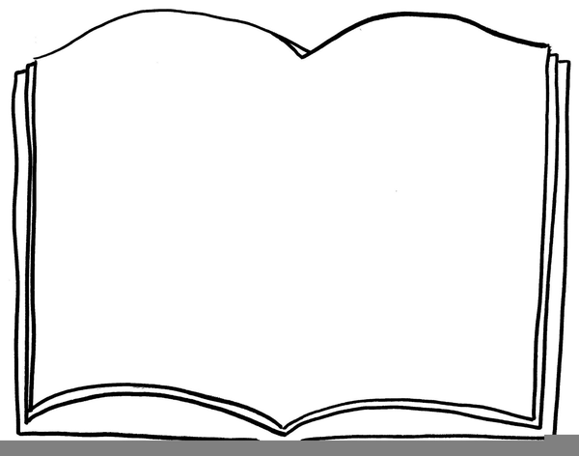

**6. Be ready with a new book!**

Good readers always have a new book ready to go when the current book is finished. Keep a list of books you want to read.

**5. Create Flipgrid videos**

You are required to read at least one independent novel each nine weeks. **You will make a Flipgrid video for your book that will be graded.** Use the rubic to help you make your video. **This is a double daily grade.**

**4. Share your reading with the class.**

You will have opportunities to share what you have read or are reading with the class. Readers love to talk about books they love! Listen closely to get ideas of books you might like to read next.

**3. Bring your novel to class every**

**day!**

You always want to have a book with you so you can read anytime you get a chance. Whenever you finish an assignment, you may read!

1. **Choose “Good Fit” books**

“Good Fit” books are books you are interested in and want to read. Have a strategy for finding new books like asking a friend, teacher, or librarian. You can also watch the Flipgrid videos to get suggestions.

1. **Set a reading goal**

You are required to read **at least one independent novel each nine weeks,** but we expect you to challenge yourself! Do your best to meet your goal and adjust your goal each quarter to reflect your progress.

