Hill Country Middle School
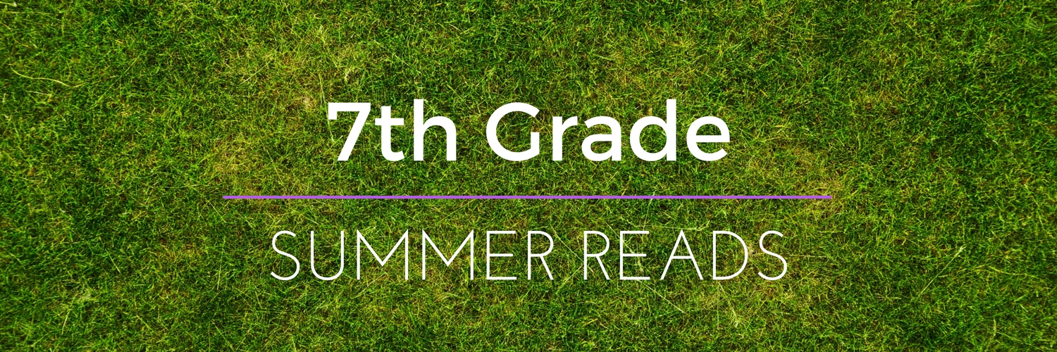
This summer you have plenty of choices for summer reading…

All students at Hill Country Middle School are encouraged to read many books this summer. “There is a strong correlation between reading regularly for pleasure (any reading...really, ANY reading, as long as it’s a habit) and academic success, including building vocabulary, an understanding of sentence structure, and an increase in stamina when reading harder texts. It is also clear that the more you read, the better you write” (Kittle 2014).

Summer reading expectations: This assignment will be taken as a participation grade. Students are required to read at least one book this summer, and complete one video booktalk using Flipgrid. The 7th Summer Reading 2019 Fligrid will be used as a starting point this fall for future discussions about great books to read.

First, join our HCMS 7th Summer Reading 2019 Flipgrid. Flipgrid is a safe and private website and app where students can create book talk videos and share what they are reading with other HCMS students. This is a great way to read!

Signing Up for Flipgrid:
Device app option: 1) Download the Flipgrid app from Self Service or App Store 2) Click on “I am a Student” 3) enter grid code 1b62809a 4) enter the password: hcms7
Computer option: 1) Click this link: https://flipgrid.com/1b62809a 2) enter password: hcms7

Now add a book talk: 1) Click on the Summer Reading box, click the plus sign, either record yourself giving a book talk or upload a talk you already recorded on your device. Please remember to include these elements in your book talk: (1) your name, (2) the book (hold up the book you are sharing); (3) book title; (4) author; and (5) a brief summary that doesn’t give away too much; plus (6) your review and thoughts on the book = what did this book make you think or feel, what did it remind you of {another book or movie?}.

Need a book recommendation?
Texas Lone Star Reading List or Middle Grade Suggestions or More Middle Grade Suggestions

Summer Reading:
Students are invited to check out up to 10 books from the HCMS Library to read over the summer. Download THIS PERMISSION SLIP, return to the Library May 21 - 25, and check out books to take home! Watch THIS VIDEO for more info!

Have a wonderful summer! Happy reading, and we look forward to seeing you in the fall.

The Seventh Grade ELA Team -
If you have any questions, please contact Brittaney Morrison bmorrison@eanesisd.net

