*Seedfolks*

Pre AP Reading Questions

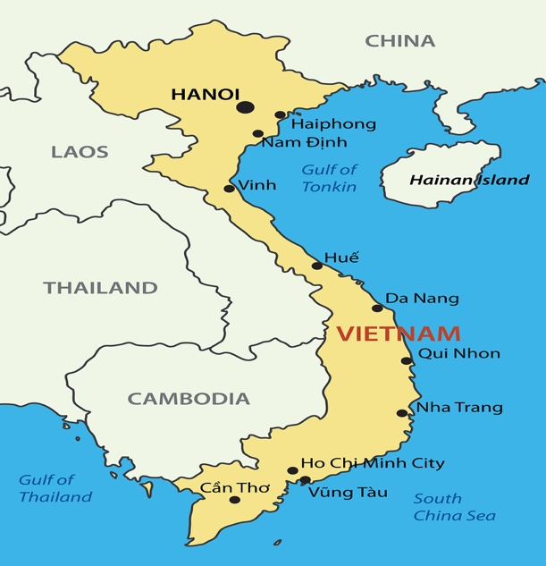

Kim

Pg. 1 - 4

Part 1 Ch. 1-7

Answer **all questions** in complete sentences unless asked to list,

fill in the blank, or multiple choice.

1. **Who** is the chapter about? __________________
2. **Where** do the events take place? _____________________
3. **When** do the events take place? ______________________

4. What does the description of the setting tell you about the neighborhood? (inference)

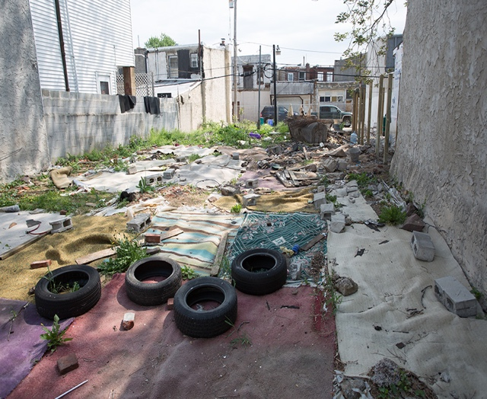

______________________________________________________

______________________________________________________

______________________________________________________

______________________________________________________

5. From what **point of view** is this chapter told? ___________________

How do you know? ____________________________________________________________________

___________________________________________________________________________________

What does a reader gain from this point of view? ____________________________________________

_____________________________________________________________________________________

6. What is the best **summary** statement for this chapter?

A. Kim sneaks out of her house and goes to the vacant lot across the street from her apartment. She digs six holes and plants lima beans to connect with her farmer father.

B. Kim looks at the photo of her father and is sad that she has no memories of him. He died before she was born, yet her mother and sister cry over the loss still.

C. Kim is sad that she never knew her father who died before she was born. In an effort to connect with her farmer father, she plants lima beans in the dirty, rundown vacant lot near her house.

D. Kim hears her mother and sister crying on the anniversary of her father’s death. Because she is sad that she never knew him, Kim begins to cry too.

**Connection**:

7. Kim plants the beans to honor her father. If you were to pay tribute to a member of your family, who

would it be and how would it honor that person?

Who? ___________________________________

What would you do/make? _______________________________________________________________

______________________________________________________________________________________

Why? __________________________________________________________________________________

_______________________________________________________________________________________

**Grammar:** (use the reference section of your Writer’s Notebook if you need help!)

8. What is a **noun**? _________________________________________________________________________

List 5 **common** nouns from the chapter and put the page number where you found the word. Ex: lips (1)

1. _____________ 2. _____________ 3. _____________ 4. ______________ 5. ______________

List 3 **proper** nouns from the chapter and put the page number where you found the word. Ex: Tom (4)

1. ______________________________ 2. ________________________________

3. _______________________________

9. What is a **conjunction**?_________________________________________________________________

List 3 **different** conjunctions from this chapter and put the page number where you found the word.

_____________________ __________________ ____________________

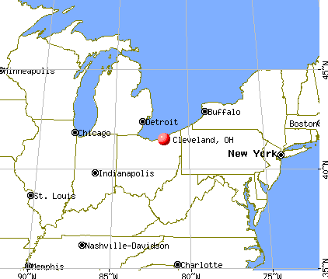

**Ana**

pg. 5 - 10

1. **Who** is the chapter about? __________________

2. **Where** do the events take place? _____________________

3. **When** do the events take place? ______________________

4. **What** is the point of view of this chapter? _________________________

1. On pg. 6, why is the neighborhood compared to a cheap hotel? (inference)

_____________________________________________________________________________________

_____________________________________________________________________________________

What kind of **figurative language** is this comparison? __________________________

6. What does Ana think when she sees a young girl digging in the lot? _____________________________

_____________________________________________________________________________________

7. Which passage from the chapter best supports the idea that Ana feels terrible about digging up Kim’s

beans? (circle **ALL** that apply)

1. *I thought of calling up the police. Then I saw her there the next morning, and I decided I’d solve the case myself.*
2. *I couldn’t see what she was doing. My curiosity was like a fever inside me.*
3. *Then the truth of it slapped me full in the face. I said to myself, “What have you done?”*
4. *I felt like I’d read through her secret diary and had ripped out a page without meaning to.*

8. What does Ana learn? (theme)____________________________________________________________

______________________________________________________________________________________

_____________________________________________________________________________________

**Connection**:

9. Anna has seen significant changes to Cleveland over her many years of living there. What changes do you

think will have occurred in Austin 50 years from now?

MCj04125540000[1]

____________________________________________________________________

____________________________________________________________________

____________________________________________________________________

____________________________________________________________________

**Grammar**: (use the reference section of your Writer’s Notebook if you need help!)

10. What is a **pronoun**? ______________________________________________________________________

1. List 5 *different* **pronouns** from this chapter and the page number where you found the word. Ex: *I* (5)

1._____________ 2. _____________ 3. _____________ 4. ______________ 5. ______________

**Wendell**

pg. 11 - 16

MCj04247340000[1]

1. **Who** is the chapter about? ____________________

2. **Where** do the events take place? _______________________

1. **When** do the events take place? _________________________

4. What is the **point of view** of this chapter? _________________________

5. From Kim’s reaction to seeing Wendell watering her plants, you can **conclude** –

A. that Kim knows and doesn’t like Wendell.

B. that Wendell doesn’t do nice things for people very often.

C. that Kim is scared because in this neighborhood there are not many acts of kindness.

D. that Kim is angry that Wendell has discovered her garden but is too afraid to say so.

6. What does Wendell learn from Kim when he thinks, "And a child shall lead them" ? (15) (theme)

_______________________________________________________________________________________

_______________________________________________________________________________________

7. At the end of the chapter you can **conclude --**

A. that Kim is so scared that she will never come back to water her seeds again.

B. that Wendell no longer feels sorry for himself and plans to

make positive changes in his life.

C. that Wendell will no longer allow Ana to boss him around.

D. that Wendell will never go back to the vacant lot again.

8. Write a **simile** or **metaphor** to describe Wendell.

______________________________________________________________________________________

Explain why this is appropriate for him.______________________________________________________

______________________________________________________________________________________

**Connection:**

9. Kim is not used to experiencing acts of kindness. Think of one act of kindness you can do for a family . member or friend. What is it? Explain. (And do it!)

______________________________________________________________________________________________________________________________________________________________________________________________________________________________________________________________________________

**Grammar**: (use the reference section of your Writer’s Notebook if you need help!)

10. What is a **verb**? _________________________________________________________________________

________________________________________________________________________________________

List 5 *different* **action** **verbs** from this chapter and include the page number where you found the word.

Ex: *got* (11)

1 ._____________ 2. _____________ 3. _____________ 4. ______________ 5. ______________

List 5 **linking** **verbs** from this chapter and include the page number where you found the word.

Ex: *was* (12)

1. _____________ 2. _____________ 3. _____________ 4. ______________ 5. ______________

List 3 *different* **verb phrases** from this chapter and include the page number where you found the words.

Ex: *could tell* (12)

1.__________________________ 2. __________________________ 3. __________________________

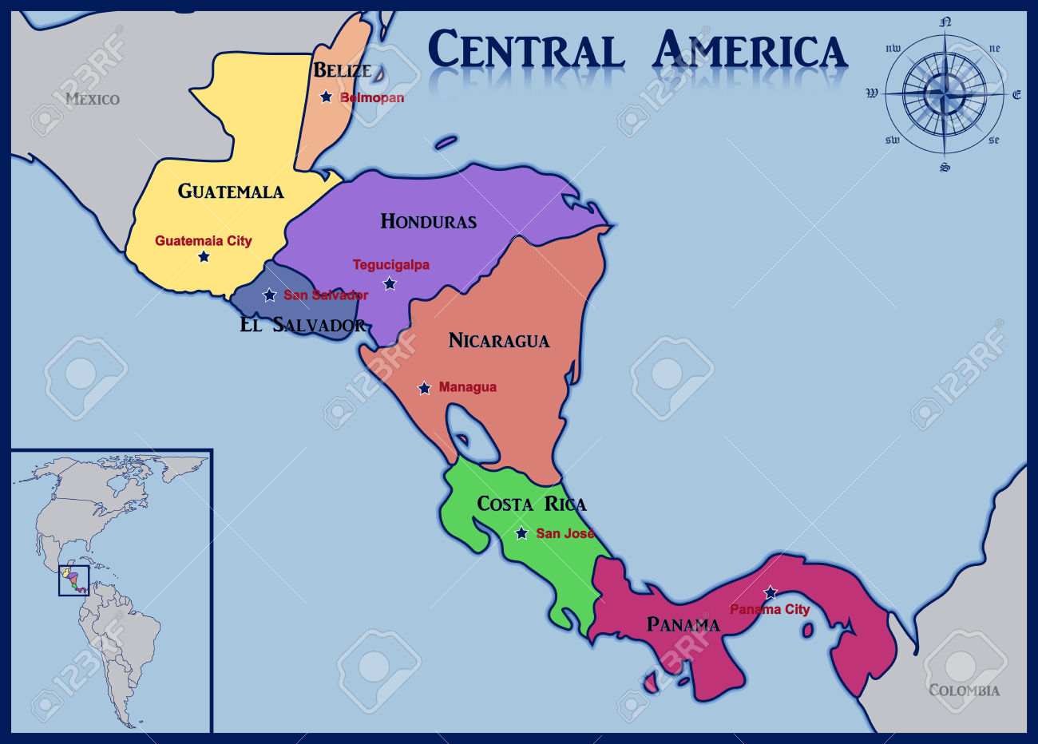

**Gonzalo**

pg. 17 - 22

1. **Who** is the chapter about? ____________________

2. **Where** do the events take place? _______________________

3. **When** do the events take place? _________________________

4. What is the **point of view** of this chapter? _________________________

5. Which words help you understand what the word ***bodega*** means?

* 1. down the block
  2. only buy food
  3. lowered his eyes
  4. mumbles and smiles

6. What does Gonzalo think about his great-uncle at the **beginning** of the chapter? _____________________

_______________________________________________________________________________________

_______________________________________________________________________________________

7. What does Gonzalo think about his great-uncle at the **end** of the chapter? __________________________

_______________________________________________________________________________________

_______________________________________________________________________________________

8. What did Gonzalo learn from this experience with his uncle? (theme) ______________________________

_______________________________________________________________________________________

_______________________________________________________________________________________

**Connection**

9. Tio Juan finds he is able to practice his passion of growing things in the garden which helps him find his manhood and dignity. What is your passion?

______________________________________________________________________________________

How does it benefit you?

______________________________________________________________________________________________________________________________________________________________________________________________________________________________________________________________________________

**Connection:**

10. If you moved to a foreign country, how do you think you would adapt? Explain what you might be thinking and feeling.

______________________________________________________________________________________________________________________________________________________________________________________________________________________________________________________________________________

__________________________________________________________________________________________

**Grammar**: (use the reference section of your Writer’s Notebook if you need help!)

11. What is an **adjective**? ____________________________________________________________________

______________________________________________________________________________________

12. List 5 *different* adjectives from this chapter **and** the noun or pronoun it is describing **and** include the page number where you found it. Underline the adjective. Ex: *oldest* man (18) *little* baby (18)

1. ______________________________________ 2. ______________________________________

3. _______________________________________ 4. ______________________________________

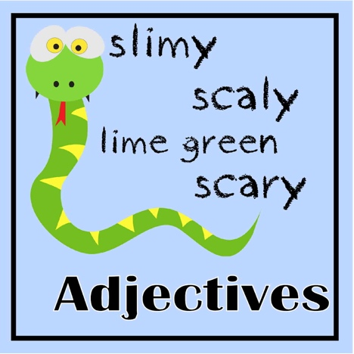

5. _______________________________________

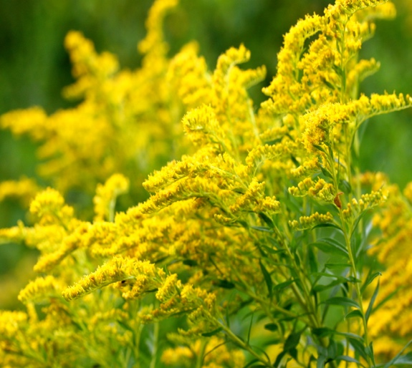

Leona

pg. 23 - 28

1. **Who** is the chapter about? ____________________

2. **Where** do the events take place? _______________________

3. **When** do the events take place? _________________________

goldenrod

4. What is the **point of view** of this chapter? _________________________

5. What does Leona think when she sees people gardening in the vacant lot? __________________________

_______________________________________________________________________________________

6. Leona says, “I’ve got two kids in a high school that’s got more guns than books…” (26). This is an example of what type of figurative language? _____________________________

What does the author want the reader understand by using this figurative language? __________________

________________________________________________________________________________________

7. Explain these **symbols**:

a. goldenrod: ____________________________________________________________

______________________________________________________________________

MCj02962080000[1]

b. trash bag: _______________________________________________________

________________________________________________________________

.

_____________________________________________________________

c. saxophone key: ______________________________________

________________________________________________

________________________________________________

8. What do you learn from reading about Leona and her actions? (theme). __________________________________________________________________________________________

**Connection**:

9. There are lots of **symbols** in this chapter. What would be a good symbol for you? _____________________ Why? __________________________________________________________________________________

______________________________________________________________________________________________________________________________________________________________________________________________________________________________________________________________________________ __________________________________________________________________________________________

**Grammar**: (use the reference section of your Writer’s Notebook if you need help!)

10. What is an **adverb**? _______________________________________________________________________

________________________________________________________________________________________

11. Circle the adverbs in the sentences below.

1. He passed away that very same summer. (24)

2. Had him a real nice funeral, later. (24)

3. She always laid some goldenrod on their graves. (24)

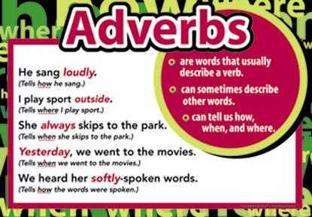 4. Then I came to the vacant lot and saw three people in different parts of it. (24)

5. Let her …hear me loud and clear. (28)



MCj02807880000[1]

**SAM**

pg. 29 - 35

pg. 29 - 35 29

1. **Who** is the chapter about? ____________________

2. **Where** do the events take place? _______________________

3. **When** do the events take place? _________________________

4. What is the **point of view** of this chapter? _________________________

5. Sam compares himself to a _________________________ mending a ____________ because he tries to mend or “fix” the world. He thinks the __________________ will “fix” the neighborhood by bringing the people together. This type of comparison is called a ______________________________.

6. How does Sam feel when he first sees the lot being cleared for gardens? _________________________

How does he feel on pg. 32 when working in the garden? ___________________________

How does he feel at the end of the chapter? _________________________

7. What does Sam learn? (theme) _____________________________________________________________

_______________________________________________________________________________________

8. What is the best **ending** for this **summary** of this chapter?

Sam, a retired social worker, is excited about the garden. He sees it as an opportunity to

bring all the different people of the neighborhood together. Sam works in the garden with people of different cultures and believe that it is a Garden of Eden.

1. People threw trash out their windows and into the garden.
2. A homeless man, unhappy that the couch had been removed from the lot, ripped out people’s plants.
3. Sam had to haul water to the garden in a wagon because there was not water in the vacant lot.
4. Sam discovers, however, that the garden is merely a small version of the neighborhood with all its segregation, distrust, and troubles.

**Figurative Language:**

Identify each statement below as a **simile** or **metaphor**. Write the word on the line.

9. I crossed to join them, like a cat who smells herring (29). _____________________________

10. I’ve just switched battlefields, from the entire planet to this corner of Cleveland (30). ________________

11. He worked the soil until it flowed through your fingers like silk (31). _________________________

12. It seemed to me that we were in truth in Paradise, a small Garden of Eden (32). ____________________

13. Water is heavy as as bricks, trust me (32). ________________________

**Connection**:

14. The garden is a perfect paradise for Sam. What is **your** perfect paradise? Explain.

__________________________________________________________________________________________________________________________________________________________________________________________________________________________________________________________________

______________________________________________________________________________________

**Grammar**:

A **preposition** is a word that starts a prepositional phrase. Prepositional phrases add details, description, and interest to writing.

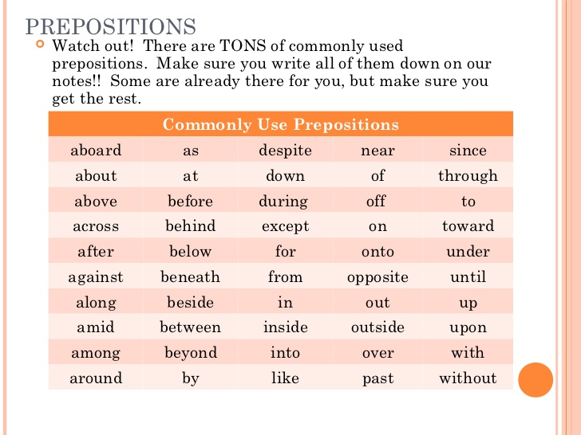

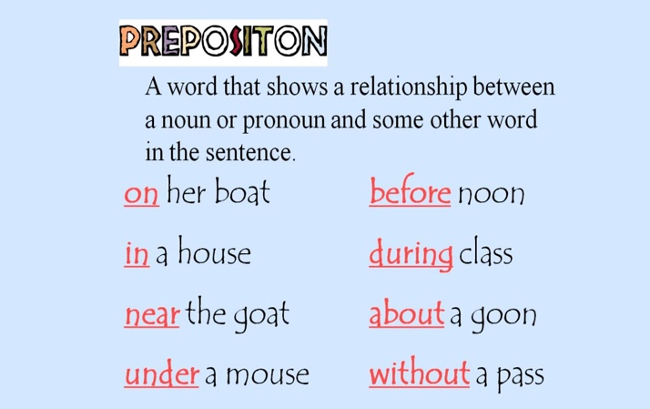

Add 10 items to the garden using a prepositional phrase to tell its location. You may also label items already in the picture to get 10 prepositional phrases. Do NOT repeat prepositions.

Example: put a sun it *in the sky*



in the sky

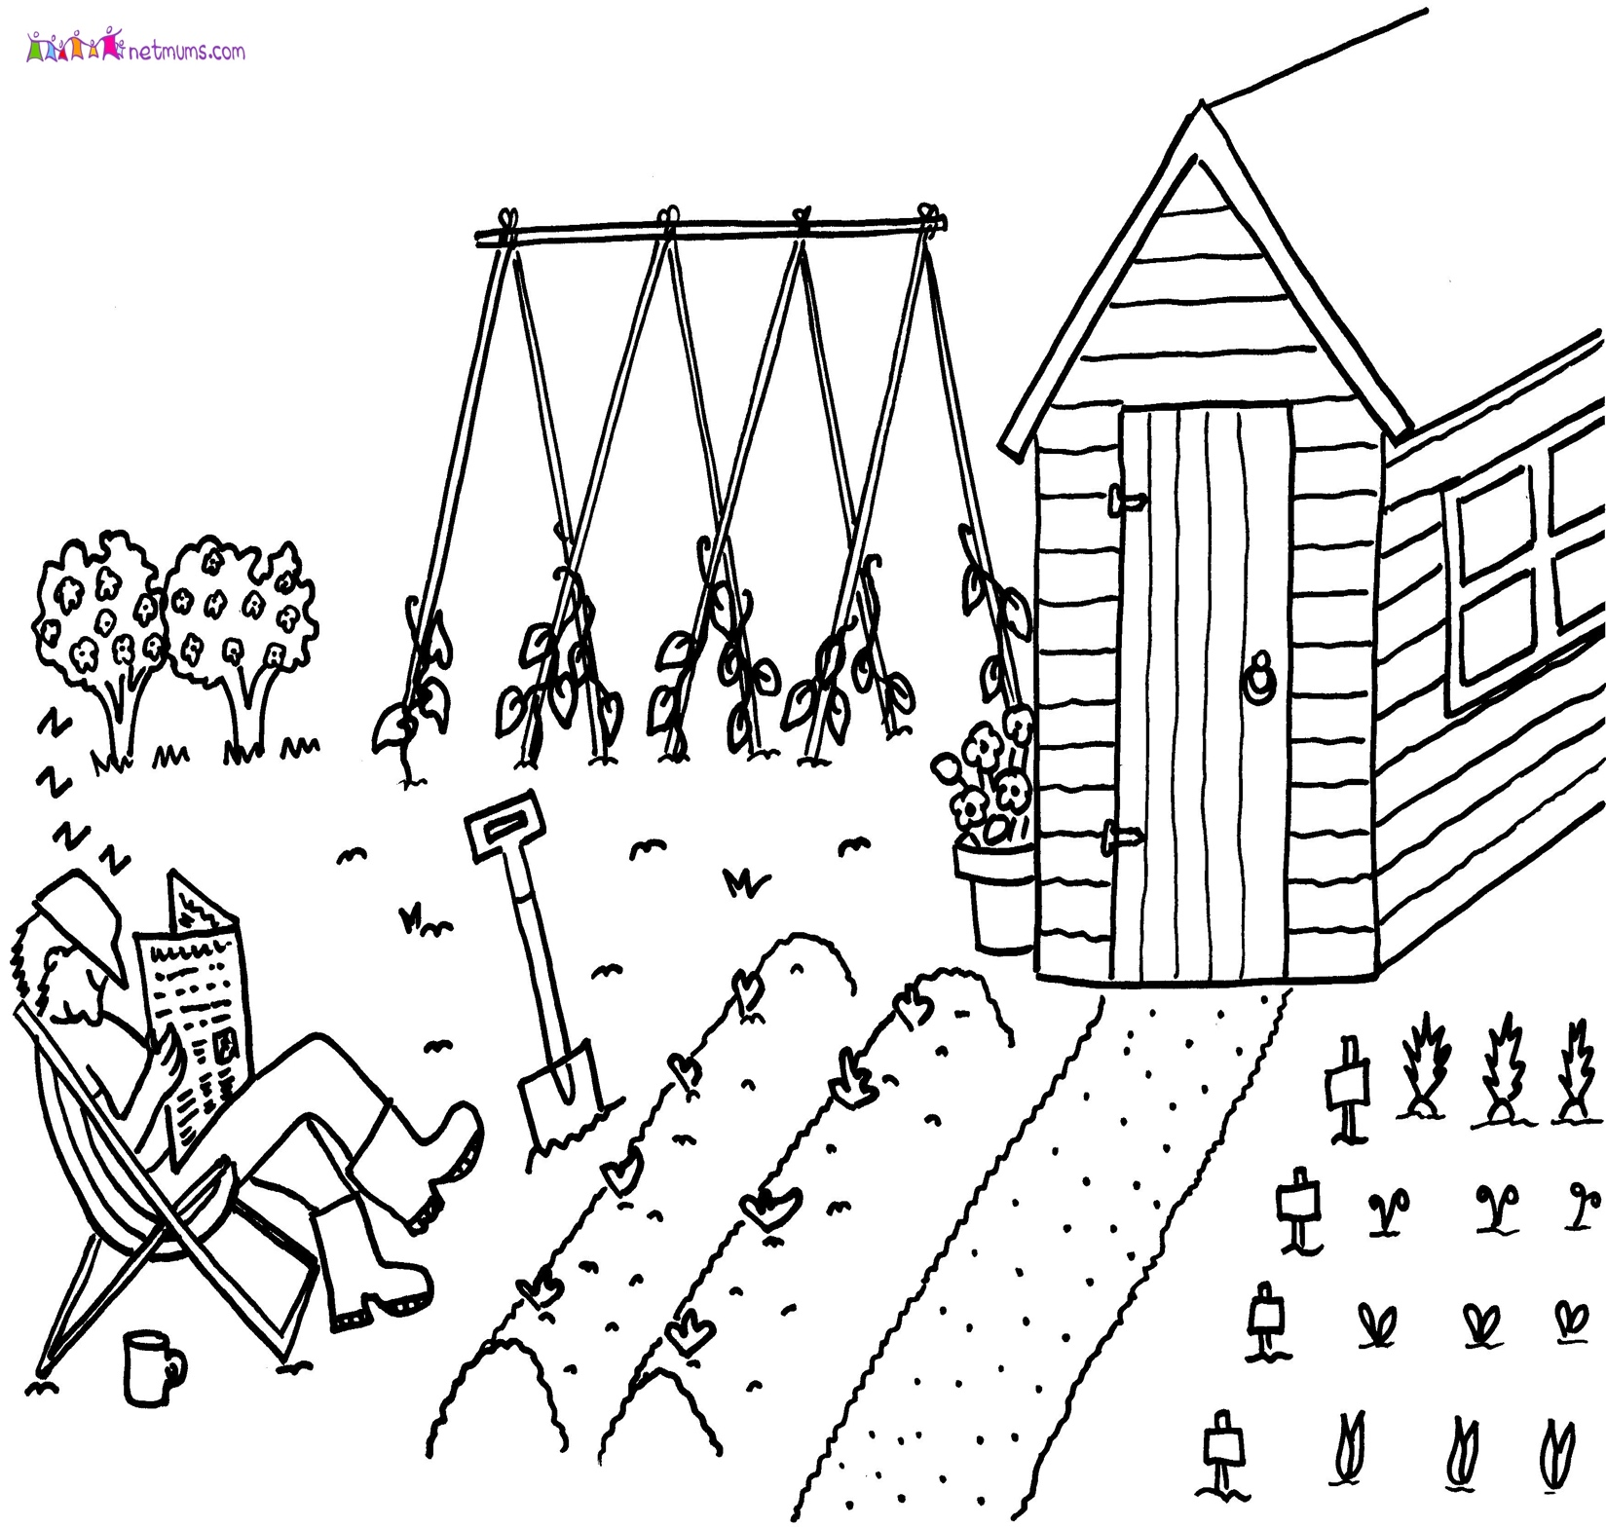



Virgil

p.36-44

1. **Who** is the chapter about? ____________________

2. **Where** do the events take place? _______________________

3. **When** do the events take place? _________________________

4. What is the **point of view** of this chapter? _________________________

**Figurative language**

5. What do the following examples of **figurative language** add to the chapter? What information do they give the reader?

A. “The dude screamed, just like women do with a mouse in cartoons, only louder” (37).

_____________________________________________________________________________________

B. “ He had a two-foot-wide smile on his face” (37).

____________________________________________________________________________________

C. “Well, Virgil,” she said. “You seem to have claimed quite a large *plantation* here”(40).

____________________________________________________________________________________

D. “His cab was like a library for him” (43).

___________________________________________________________________________________

6. Which word best describes Virgil’s father? (circle your answer)

caring greedy happy clever

7.  **Give** two pieces of **textual evidence** from the chapter that proves your choice above.

A.

B.

8. When Virgil’s father is talking to Miss Fleck about the garden he is planting, you can tell that Virgil is…

1. used to hearing his father lie.
2. shocked to hear his father lie to his old teacher.
3. glad his father is able to plant such a large plot of land.
4. proud of his father for thinking up such a creative story.

9. **Connection** – choose ONE from below to write about.

Have you ever been surprised or disappointed in If you had a special locket, whose picture would the actions of an adult? What did that experience you put in it? Why? teach you?

_________________________________________________________________________________________________________________________________________________________________________________________________________­­­­­_________________________________________________________

______________________________________________________________________________________

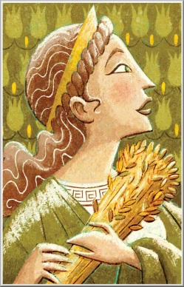

In [ancient Greek religion](http://en.wikipedia.org/wiki/Religion_in_ancient_Greece) and [myth](http://en.wikipedia.org/wiki/Greek_mythology), Demeter is the goddess of the harvest, who presided over [grains](http://en.wikipedia.org/wiki/Grain) and the [fertility](http://en.wikipedia.org/wiki/Fertility) of the earth.

**Grammar review:**

Lettuce seeds are smaller than sand. I felt embarrassed, planting so much ground. No one else’s garden was a quarter the size of ours. Suddenly I saw Miss Fleck. I hardly recognized her in jeans. She was the strictest teacher in Ohio. I’d had her for third grade. She pronounced every letter in every word, and expected you to talk the same way. She was even taller and blacker than my father. No slouching in your seat in her class or any kind of rudeness. The other teachers seemed afraid of her too. She walked over just when we finished planting.

“Well Virgil,” she said. “You seem to have claimed quite a large *plantation* here.”

1. **Nouns** – List 5 different nouns from this passage. At least one must be a proper noun.

_______________ _______________ _______________ _______________ _______________

1. **Pronouns** – List 5 different pronouns from this passage

_______________ _______________ _______________ _______________ _______________

1. **Verbs – do not repeat verbs**
2. List three action verbs __________________ __________________ __________________
3. List three linking verbs __________________ __________________ __________________
4. List one verb phrase _______________________________
5. **Adjectives** - List 5 different adjectives from the passage

_______________ _______________ _______________ _______________ _______________

1. **Adverbs** – List 3 different adverbs from this passage

_______­­­_____________ ____________________ ____________________

1. **Conjunctions**  - List two different conjunctions from this passage _______________ ______________
2. **Prepositions** – list 5 **prepositional phrases** from the passage above.

____________________________________________________________

____________________________________________________________

____________________________________________________________

____________________________________________________________

____________________________________________________________

1. Can you find the **interjection** in this passage??? _______________________