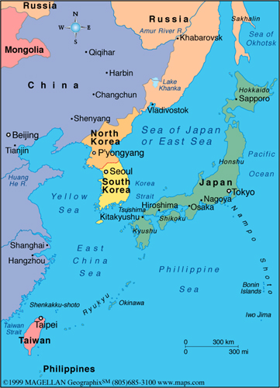Seedfolks Pre AP

Reading Questions Part 2

Sae Young

p.45-50

Answer in complete sentences unless short answer

or multiple choice.

1. What awful events happen to Sae Young?

_________________________________________________________

_________________________________________________________

_________________________________________________________

2. How does she feel after the attack? ______________________________________________________

3. What is the problem in the garden?________________________________________________________ ________________________________________________________________________________________

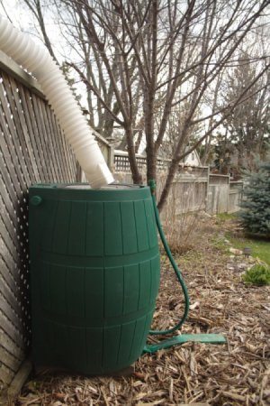

4. Who solves the problem and how?

_________________________________________________________________

_________________________________________________________________

_________________________________________________________________

_________________________________________________________________

5. How does Sae Young feel in the garden? ____________________________

______________________________________________________________

6. What does the way Sae Young speak reveal about her?

__________­­­­­­­­­­­­­­­­­­­­___________________________________________________________________________

______________________________________________________________________________________

7. What does Sae Young learn? (theme) _______________________________________________________

______________________________________________________________________________________

Connection:

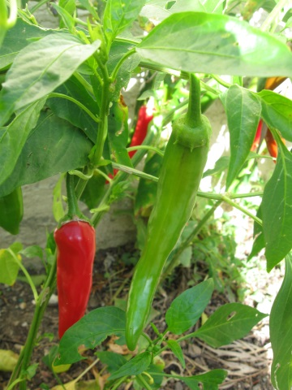 8. Sae Young overcomes her fears. What are you afraid of? How could you overcome it?

hot peppers

______________________________________________________________________

______________________________________________________________________

______________________________________________________________________

______________________________________________________________________

_____________________________________________________________________

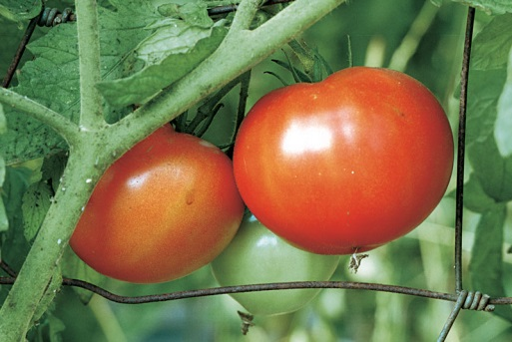

Curtis

p.51-58

1. Why is Curtis growing the tomatoes? _________________________________

____________________________________________________________________

2. Why does the author compare Curtis to *Atlas* on pg. 51? What does it help the reader understand?

__________________________________________________________________________________________

3. In what ways has Curtis changed over the years? Give 2 specific examples.

______THEN____________________________________________NOW__________________________

a. a.

b. b.

4. What does the way Curtis talk reveal about him? _____________________________________________

_____________________________________________________________________________________

5. Who is Royce? ­­­­­­­­­­­­­­__________________________________________________________________________

________________________________________________________________________________________

6. What is one **theme** revealed in this chapter? (there are many – chose one) ______________________________________________________________________________________________________________________________________________________________________________

7. Do you think Curtis will win Lateesha back? ____________ Why? Explain.

________________________________________________________________________________________________________________________________________________________________________________________________________________________________________________________________________

**Grammar: Sentences**

* A sentence is a group of words that expresses a complete thought.
* A sentence begins with a capital letter and ends with punctuation -- . ? !
* A sentence needs a ***subject*** (noun or pronoun) and **verb**.
* Sometimes the verb is not a single verb but a verb phrase.

**SUbject + Verb (phrase) = Simple Sentence**

**Who or What the sentence is about? What the subject is doing**

**or is like**

The subject and verb of a sentence will NOT be in a prepositional phrase!

The gardeners had made a trail through it.

It was a job for the phone.

Draw a line through the prepositional phrases (if any) in the sentences below. Then, **underline the subject once** and **the verb twice** in the following sentences.

1. I really was not listening too hard.
2. She was looking for a husband.
3. She lives straight across the street from the garden
4. She had a serious thing for tomatoes.
5. My plants were right there near the sidewalk.
6. One of the gardeners had seen Royce’s shape in a pile of grass clippings.
7. He had been sleeping there nights.
8. I found him a spot closer to my tomatoes.
9. His part of the deal was to guard my tomatoes.
10. As still as a cat, behind that lace curtain, her face was staring down at the sign.

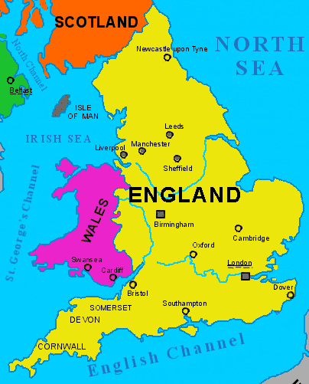

Nora

p.59-65

1. How does Nora feel about Mr. Myles? ______________________

______________________________________________________

_____________________________________________________

1. What kind of person is Nora? How do you know? Give evidence from the text.

3. What effect does the garden have on Nora and Mr. Myles?

____________________________________________________________________________________ ____________________________________________________________________________________ ____________________________________________________________________________________

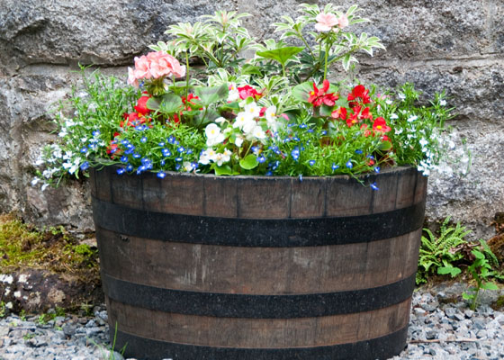

4. The statement that best **summarizes** a **theme** of this chapter is:

A. Friends need to work together.

B. When given a purpose, what seems to be and old and useless can become renewed and useful.

C. Nora is kind and works hard to care for Mr. Myles.

D. Even a person with a handicap can still participate in gardening.

1. Choose your favorite metaphor from page 63. Copy it and explain what it means –what the author wants the reader to understand with this comparison.

Metaphor Explain what it shows

1. Which character from the novel would you say Mr. Myles is most like?

Kim Ana Wendell Gonzalo Tio Juan Leona Sam Virgil

Why? __________­­­­­­­­­­­­­­­­­­­­___________________________________________________________________________ ____________________________________________________________________________________________________________________________________________________________________________________

**Connection:**

1. Do you reuse/recycle? Think of something that you could reuse. What is it and how could you reuse/repurpose it? (be creative)

_________________________________________________________________________________________________________________________________________________________________________________________________________________________________________­­­_____________________________________

_________________________________________________________________________________________

_________________________________________________________________________________________



Maricela

p.66-72

-

1. How does Maricela **feel** at the beginning of How do you know? Give evidence from the text.

the chapter?

1. What does she **think** at the beginning of the How do you know? Give evidence from the text.

Chapter?

3. From information in the chapter, you can conclude that the **stereotype** of teen moms is --

* 1. that birth is natural and something to be respected
  2. that they are terrible mothers and don’t take care of their babies.
  3. they are extremely careful during pregnancy to care for the baby.
  4. they love to garden and eat the healthy vegetables.

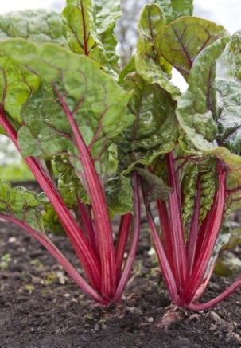

4. What does Leona help Maricela understand? (theme)

___________________________________________________

___________________________________________________

___________________________________________________

___________________________________________________

___________________________________________________

Swiss chard

**Connection:**

5. Leona gives Maricela good advice and supports her through a difficult time. Who can you turn

to for help when you need it? Explain.

______________________________________________________________________________________

______________________________________________________________________________________

______________________________________________________________________________________

**Every sentence must have a subject and a verb.**

Sometimes there is **more than one subject** in a sentence. This is called a **compound subject**. Compound subjects have the same verb are joined by a *conjunction*: *for, and, nor, but, or, so, yet =* FANBOYS*!*



My **friends** *and* **I** walked home. The **kittens** *or* **puppies** were for sale.

Sometimes there is **more than one verb** in a sentence. This is called a **compound verb**. Compound verbs have the same subject and are joined by a conjunction: *for, and, nor, but, or, so, yet =* FANBOYS*!*



We **walk** *or* **jog** to school.

My brother *and* sister **took** my game *and* **were playing** it.

Remember: subjects and verbs will NOT be in a prepositional phrase!

Underline the subjects once and the verbs twice in the following sentences. Think carefully; they may be compound!

1. He twisted and pointed toward the garden.

1. I turned the wheel chair and headed back.
2. His nose and eyes were working.
3. I stopped at the garden and unloaded a large plastic trash barrel and a shovel.
4. He weeded and watered with great concentration.
5. Penny saw the garden and got the program its own spot.
6. Radishes, squash, and Swiss chard grew in their garden.
7. He would drive up in a cab, slam on the brakes, run through our squash, cut a bunch of lettuce, and run back with it in a bucket of water.
8. 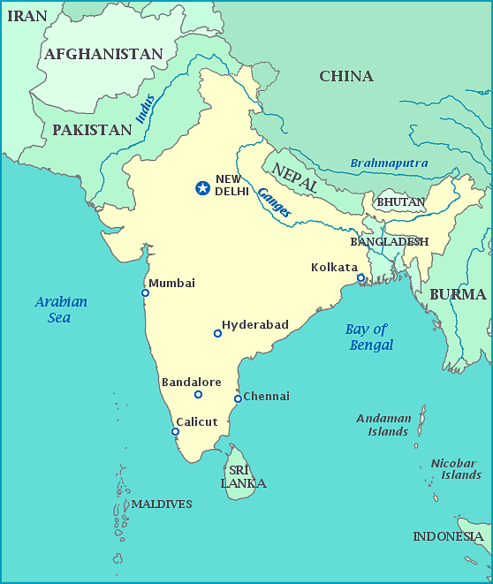Maricela, Yolanda and Dolores did not like working in the garden.

Amir

p.73-81

1. How does Amir compare and contrast India and America?

America India

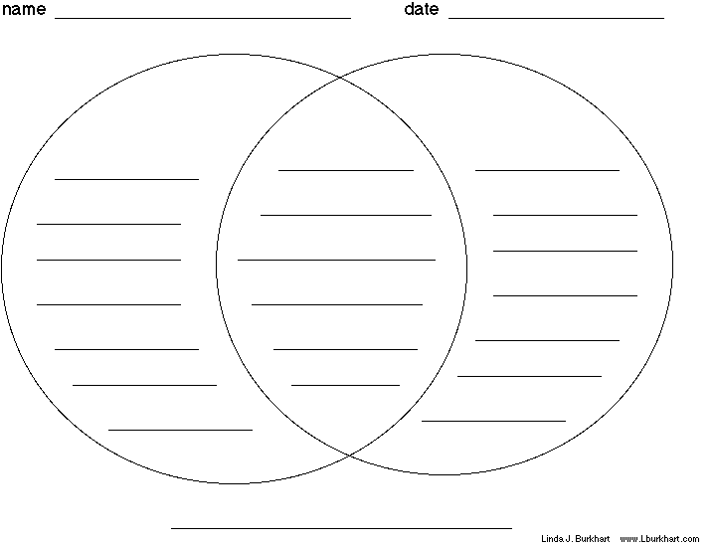

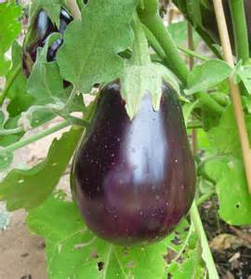

2. The eggplant is a symbol of ___________________________________________.

3. Amir makes some powerful comments/observations in his chapter about the neighborhood and society. Match the quotes from the text with their meanings.

_____ . “Here you have a million crabs A. It is important to really see and get

living in a million crevices” to know the people who live in your

( 73). community.

_____ . “the gardens greatest benefit… B. The garden teaches the neighbors

was to make the eyes see our to be generous with each other.

neighbors” ( 74).

_____ . “I realize how useless was all I C. In the US people tend to keep to

that I’d heard about Poles, how themselves and not know their

much richness it hid, like the neighbors.

worthless shell around an

almond” ( 77).

_____ . “And we gave food away, as we D. When you get to know a person,

often did…even I…trained to you treat them better; it is

give away nothing to always easier to be mean if you don’t

make a profit…” ( 80). know them.

_____ . “she called me a ‘dirty foreigner’… E. Stereotyping people keeps you

She apologized to me …saying, from getting to know the value

‘back then, I didn’t know it was and beauty of the true person

you...” ( 81). hidden inside.

4. The garden helps the neighborhood see beyond the **stereotypes** they have of each other's cultures. The character of Royce is a good symbol of this change.

A. What do people think of Royce when they first see him in the garden?

__________________________________________________________________________________________________________________________________________________________________________________________________________________________________­­­____________________________________________

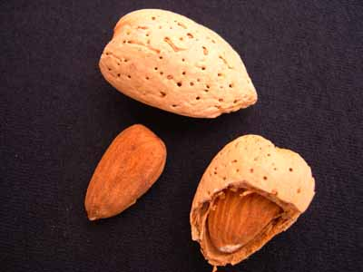

almond

B. What do they realize about him when they get to know him?

_______________________________________________________

_______________________________________________________

_______________________________________________________

_______________________________________________________

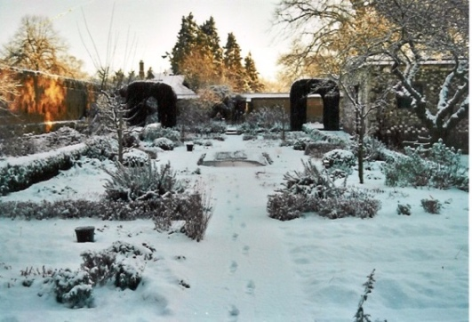

Florence

p.82-87

1. What does Florence mean by "seedfolks"? ________________

____________________________________________________

____________________________________________________

2. Tell two **themes** revealed in this chapter:

A. ___________________________________________________________________________________

B. ___________________________________________________________________________________

3. Even though she cannot work in the garden, Florence is proud of it. Why?

____________________________________________________________________________________________________________________________________________________________________________________4. How did the book begin? ___________________________________________________________________

5. How does this book end? ___________________________________________________________________

child’s sampler

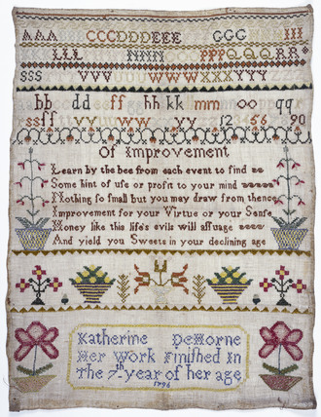Connection:

Florence uses the saying, “Be not solitary, be not idle” from her grandmother’s sampler as a guide for how to live her life.

What would **your** “sampler” say?

What is a saying/quote/ message that guides your life?

Create a “sampler” in the box below that shows your philosophy of life.

A sampler is a piece of decorative piece of embroidery made to demonstrate the maker’s skill at needlework. These works of art often revealed the values of the girl who made it.

6. What is the best **summary** of the novel?

A. In the middle of a tough neighborhood in Cleveland, Ohio, there is a vacant lot filled with refuse and

infested with rats. Strangers turn the lot into a garden and make friends.

B. Strangers come together to turn a rundown lot into a garden in the middle of a tough neighborhood in Cleveland, Ohio. A little girl inspires the strangers. During the process, the little girl and the strangers become friends.

C. In the middle of a tough neighborhood in Cleveland, Ohio, there is a vacant lot with refuse and infested with rats. Inspired by a little girl, a group of strangers turn the lot into a garden. In the process, they discover the gift of community.

D. A little girl inspires a group of diverse strangers in a tough neighborhood of Cleveland, Ohio. The strangers converge upon the lot and make it into a garden and decide they want to all be friends.

**Compound sentences**

When two sentences are joined together as one, it is called a **COMPOUND SENTENCE**. Compound sentences can be joined by a **comma + conjunction** or a **semicolon**.

I walk to school, ***but*** my friend rides the bus. My brother took my game, ***and*** he played it.

complete sentence complete sentence complete sentence complete sentence

Do not confuse compound sentences with a sentence that has a compound subject or verb. These are called **SIMPLE SENTENCES.** A simple sentence has one subject (may be compound) and one verb (may be compound)

My friend ***and***  I walk to school. My brother took my game ***and*** played it.

fragment complete sentence complete sentence fragment

**Simple sentence** with a compound subject

**Simple sentence** with a compound verb.

A **compound sentence** has a sentence on both sides of the conjunction.



Sentence, Sentence.

;

for

and

nor

but

or

yet

so

subject and verb subject and verb

A semicolon can be used instead of a comma + conjunction to make a compound sentence.

This comma is VERY important! Without the comma, it is a run-on sentence.

Look at these sentences from *Seedfolks*:

The fruit-seller’s carts **and** coal wagons were pulled down the street by horses back then.

(**simple sentence** with a compound subject – there is NOT a sentence on both sides of the conjunction)

They had picked themselves up **and** were looking fine.

(**simple sentence** with a compound verb – there is NOT a sentence on both sides of the conjunction)

We all complained, **but** Penny just smiled. (**compound sentence** – sentence on both sides of the conjunction)

He had been a farmer, **yet** here he couldn’t work. (**compound sentence** – sentence on both sides of the conjunction)

I took his hand, **and** he pulled me through the trash and into the lot. (**compound sentence** – sentence on both sides of the conjunction)

Identify the sentences below as simple or compound. Begin by **highlighting the conjunction**.

Write **S** on the line if it is **simple** and **C** on the line if it is **compound. Add punctuation if needed.**

Example: May **and** Sally walked to school. ___S___

John went to the store, **but** he forgot his wallet. ____C____

**(add the comma)**

1. Jack and I are playground monitors. __________

2. We watch for problems and solve them. ________

3. Students must follow the rules or they lose outside time. _________

4. During recess, most of the children play soccer or swing. ________

5. Our class went early to recess so we got the soccer ball first. ________

6. Some of the boys kicked the ball around but wouldn’t let everyone play. ________

7. Mrs. Jones called the boys over and talked to them. __________

8. She explained the rules and asked the boys to follow them. _________

9. The boys gave the soccer ball to Mrs. Jones but they still had to sit out for 10 minutes. ______

10. The students got the soccer ball they played a game all recess. _______

11. When the bell rang, the students did not want to go in yet they knew that they had to. ______

12. Neither the students nor the teachers were eager to go inside. ______

Community Gardens

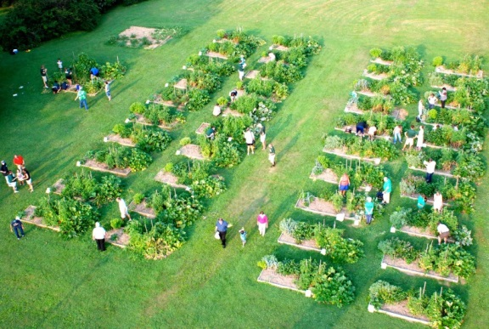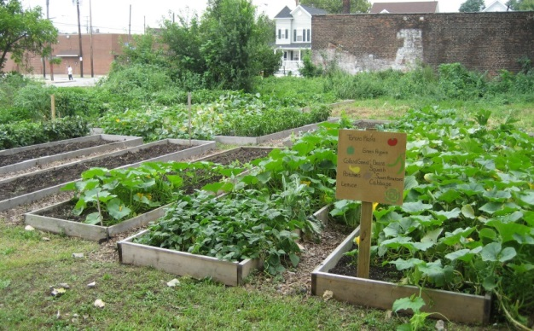

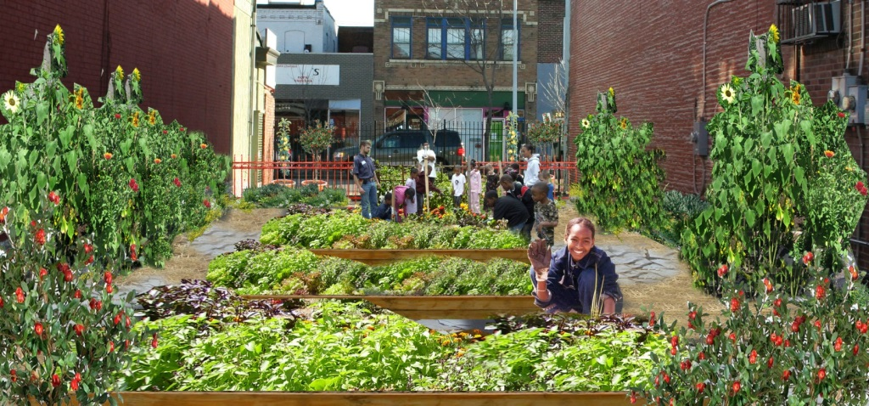

MCj04104650000[1]