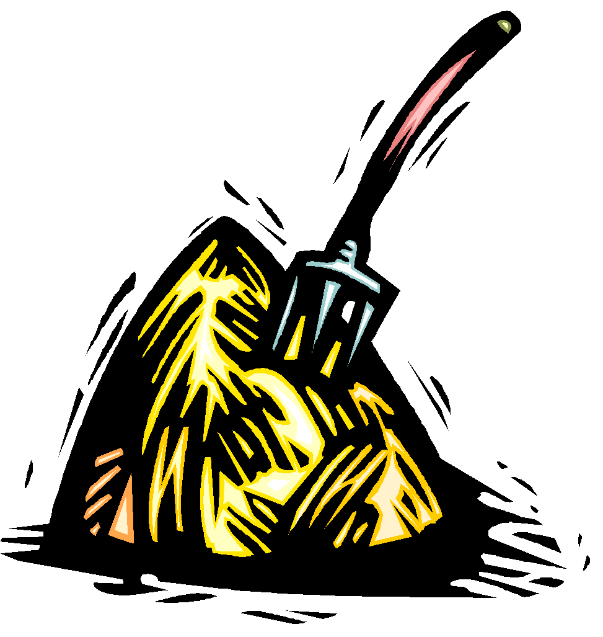
The Thief and the Beanstalk
Chapters 1-6
(Exposition and Rising Action )

All questions must be answered in complete sentences unless multiple choice or fill in the blank.

Chapter 1 (pgs. 1-5)

Focus: characterization, conflict, point of view

- From whose point of view is chapter 1 told? _____________________________

- What does the conflict between Nick and the farmer help the reader to understand about Nick’s character?

Type of Conflict & Describe Conflict | What does it reveal about the character (Nick)?

3. Direct or indirect characterization? Please circle direct or indirect…IF indirect, tell what it
shows/reveals about the character…

A. direct or indirect? “…at Nick’s thin nose, brown eyes, and tangled mop of
brown hair…” (2)

tells what? __________________________________

B. direct or indirect? “…beating the dog, cursing at his wife, twisting the neck
of a rooster that pecked his ankle too many times” (2)

tells what? ___________________________________

D. direct or indirect? “The farmer had a bad leg that would not straighten, and
could only hobble along in slow pursuit.”(3)

tells what? ___________________________________

Chapter 2 (pgs. 6-18)

Focus: point of view, antagonist, characterization, setting, flashback, foreshadowing

- From whose point of view is Chapter 2 told? ____________________

Circle the type of point of view in this chapter.

1st person 3rd person limited 3rd person omniscient

Textual Evidence and Citations

A citation is when you want to use the author’s exact words to provide textual evidence to support an idea or prove a point. When you cite you copy the author’s words exactly as they appear in the text in quotation marks and put the page number at the end in parenthesis followed by a period.

Here is what a citation looks like:
author’s exact words

“Finch was by far the bigger of the pair, handsome and powerfully built, with a neatly trimmed mustache and a little triangle of a beard” (6).

page number where the words were found followed by a period

This is a citation about characterization. Notice how the words are copied exactly from the novel and are inside quotation marks to show that the words belong to the author. At the end of the citation, the page where that information was found is put in parenthesis.

When citing from different parts of a sentence or paragraph, use an ellipsis (…) to show that some words were skipped.

Example: To prove that Finch is a cruel man, this citation is textual evidence --

“Finch roused the rest of the band…kicking the ones who woke too slowly…but they feared Finch too much to complain” (11).

The ellipsis indicates to the reader that some words were left out. Only the words that are important to proving the point have been included.

When a citation extends over two pages, simply put both pages in the parenthesis.
Note these citations. The ellipsis shows that information has been left out at the beginning, middle, or end.
Example:
“…Old Man Jack’s house. House? Fortress is a better word for this place…” (7).

“He stood a head taller than the rest...most of the hair on his head was gone” (13).

2. Draw Toothless John:

Cite 2 examples of textual evidence to prove that your drawing is accurate:

A. ___________________________________________________________________________

B. ___________________________________________________________________________

3. What traits does Finch possess that make him a good antagonist?

____________________________________________________________________________

____________________________________________________________________________

Making inferences and drawing conclusions: finish the sentence

4. Finch says: “ ‘So I’m off to recruit a new member of our gang. A temporary member, you might say,’ Finch drew his favorite object in the world from the sheath of his hip: a large jagged knife, kept dangerously sharp. He ran his finger along the face of the blade as he spoke” (11).

From this quote, you can infer that the author is foreshadowing-

_______________________________________________________________________________

_______________________________________________________________________________

5. “Wherever they went, Finch would seek out the storytellers…from the stories, he imagined he could get a fix on where Jack’s house might be…Many seasons had passed. Finch was certain he was drawing closer” (14).

From this quote, you can conclude that -

_______________________________________________________________________________

_______________________________________________________________________________

6. “As for the minstrel, that was the end of his song” (15).

From this quote, you can conclude that -
_______________________________________________________________________________

_______________________________________________________________________________

7. No, you’ve got to find a kid who’ll be glad to help you—a kid no one will miss, with no place to go (18).

From this quote, you can infer that the author is foreshadowing-
_______________________________________________________________________________

_______________________________________________________________________________

8. Why does the gang need a child to help them?

____________________________________________________________________________

____________________________________________________________________________

Ch. 2 continued
on next page

NOUNS

Nouns name a person, place, thing, or idea.

Concrete nouns name nouns that you can see and/or touch like – boy, cow, pitchfork

abstract nouns name a noun that cannot be seen and/or touched like – friendship, hope, love
These are more difficult to identify as nouns.

Circle all the nouns in the following sentences – some will be abstract.

- “He did not care if the legend was true or not” (6).

- “Slightly built Squint was the exception, but there was a reason” (6).
- “Finch had no patience for this speculation” (8).

- “Finch dreamed about Jack’s gold all night” (10)

- “His greedy desires woke him early the next morning” (10)

- “There were groans of displeasure” (11).

- “And deal with disobedience however you like” (12)

- “Finch’s dark heart thumped with glee” (16). Watch this short video to learn
more about abstract nouns.

Chapter 3 (pgs. 19-26)

Focus: conflict, indirect characterization, figurative language

- What is Nick compared to in the simile on pg. 19? _______________________

Why did the author choose to describe Nick this way?

_____________________________________________________________________________

______________________________________________________________________________.

- On page 22, the author says that, “…this stranger [Finch] radiated danger the way a bonfire threw off heat” (22). What is the author showing the reader with this metaphor about the character of Finch?

_____________________________________________________________________________

______________________________________________________________________________

- “Nick jumped to his feet and turned to run, but powerful hands seized him from behind- one on his arm and the other grabbing a handful of hair” (22).

The above quote is an example of what type of conflict? ______________________________

4. Consider Nick’s thoughts/reactions to the abandoned farmhouse and Finch’s comments about the plague. What can you conclude about Nick’s past?

________________________________________________________________________________

________________________________________________________________________________

________________________________________________________________________________

5. Appearance vs Reality Think about what you know about the character of Finch.

Describe Finch’s appearance | What is the truth about Finch’s character?
2.  3. | 1.  2.  3.

What is the author’s purpose in creating a character whose appearance and actions are so opposite?

6. If you were Nick, would you accept Finch’s offer? Why or why not?

________________________________________________________________________________

_________________________________________________________________________________

_________________________________________________________________________________

PRONOUNS

A pronoun is a word that takes the place of a noun.

“Rocks were plentiful here. The farmer had used them to build low walls around his vegetable fields” (20).
“them” takes the place of the noun “rocks” and “his” takes the place of the noun “farmer”

Common personal pronouns include he, her, him, I, it, me, she, them, they, us, and we.
Possessive pronouns include my, mine, our, ours, his, hers, their, theirs, its, yours

These are not the only pronouns.

Other common pronouns include indefinite pronouns that take the place of a noun but do not refer to any specific person or thing; they are “not definite”. Common indefinite pronouns include –
someone, anyone, no one, everyone, somebody, anybody, nobody, everybody, something, anything, nothing,

Other pronouns include who, whom, himself, herself, themselves, itself, myself, and more.

Use your Grammar and Writing Handbook to see more pronouns.

Circle the all pronouns in the following sentences

- “Does everyone understand that?” (11).

- “The sun was extinguishing itself on the watery horizon” (16).

- “Two of the men were strapping specimens who looked like they could take care of themselves in a fight” (17).

- “No, you’ve got to find a kid who’ll be glad to help you – a kid no one will miss…” (18).

- “He raced over and was clawing through the weeds, uprooting anything that looked like a carrot, turnip, or onion, when he heard something from the direction of the ridge” (20).

- “Nick lowered himself until he was hidden among the weeds” (21).

- “See, I understand everything about you,, though I never met you before this moment” (24).

- “But nobody ever did” (24).

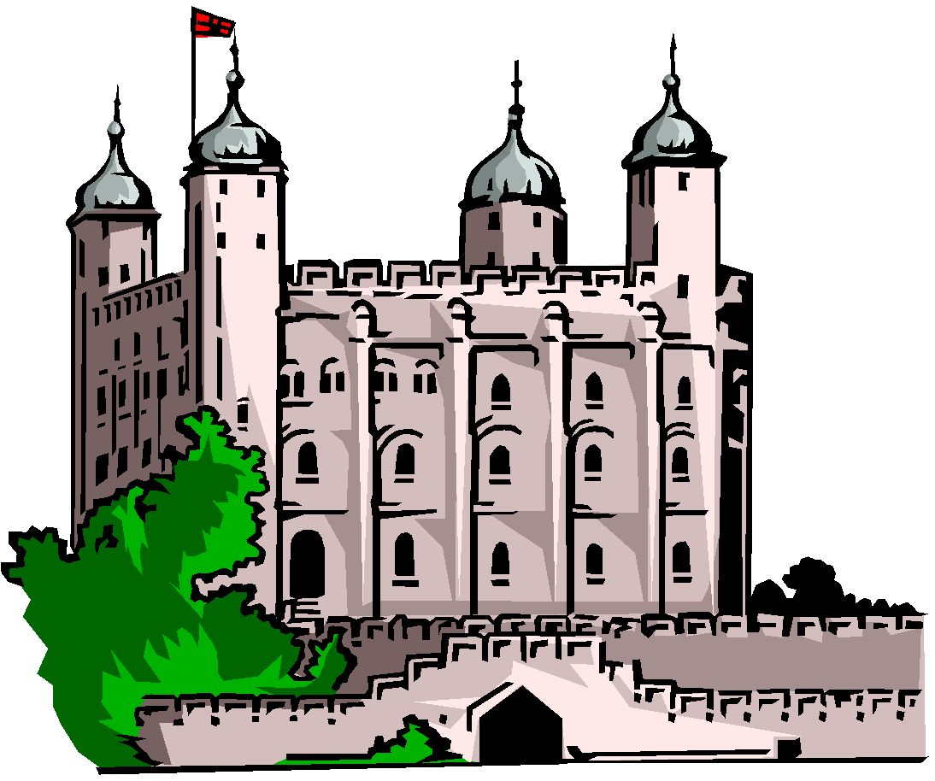

Chapter 4: (pgs. 27-35)

Focus: complications, foreshadowing, figurative language

1. Infer: Why does Finch force Nick to climb the tree before allowing Pewt to feed
him? (complication for Nick)

___________________________________________________________________________________

___________________________________________________________________________________

___________________________________________________________________________________

2. Find a simile on pg. 33 describing Finch. What is Finch compared to? ________________________

What is the author’s purpose with this comparison?

___________________________________________________________________________________

___________________________________________________________________________________

3. What does the story of Finch tracking Montescue foreshadow?

___________________________________________________________________________________

___________________________________________________________________________________

4 The author probably wrote this chapter to- (author’s purpose)

  - show how dangerous and relentless Finch is as a gang-leader.
  - show that Nick is hungry and eager to help Finch.
  - introduce the gang.
  - introduce the character of Montescue.

Chapter 5 (pgs. 36-46)

Focus: indirect characterization, foreshadowing, figurative language

1. What does the following quote reveal about Nick: “As Nick watched the savage attack, he suddenly
found the situation not funny at all” (40) . (indirect characterization)

- Nick is sickened by the sight of blood.
- Nick lacks a sense of humor.
- Nick is sensitive and doesn’t want to hurt others.
- Nick doesn’t think it is funny when they tease the driver.

2. Explain how the robbery of the wagon is a test of Nick’s character.

__________________________________________________________________________________

__________________________________________________________________________________

3. Why does Finch decide to attack Jack’s house earlier than planned?

__________________________________________________________________________________

__________________________________________________________________________________

4. Which quote is an example of foreshadowing?

- “Finch walked nearby, observing. He’d come close to losing the boy.”(45)
- “Nick kept his eyes on the driver’s back, afraid the man would turn and see him. But the driver was unsuspecting…”(38)
- “And as for what would happen after the door was open, the boy must know nothing of that at all...reaching to his side, he gave his jagged knife a gentle squeeze.” (46)
- “…Finch closed is eyes, bared his teeth, and pounded his palm with his fist. He felt like he might explode.”(43)

5.
What is the gang’s opinion of books?  (metaphor on pg. 44) | Support with text evidence.

SUBJECTS

Nouns and pronouns can function as the subject of a sentence.

The subject tells who or what the sentence is about.

Example: “Finch smirked at him” (37) . This sentence is about the noun Finch.
“I am” (37). The sentence is about the pronoun I.

Remember, the subject of the sentence will NOT be in a prepositional phrase.
“A pang of hunger clawed at Nick’s gut” (20). of hunger is a prepositional phrase

Underline the subject(s) of the following sentences.

- “Then, exhaustion overtook him” (32)

- “Someone woke him with a whispered warning…” (32).

- “Nobody dared to touch it, or look inside to see if the jewels were still there” (35).

- “The entire band hid on the opposite side of the forest road” (37).

5. “The volume of clattering hooves jumped as the wagon drew near the bend” (38).

6. “At any moment, the rope would pay out completely” (39).

7. “It twanged like the string of an instrument” (39).

8. “Finch laughed first and the rest of the gang echoed him” (41).

7. “The poor fellow dropped headfirst to the ground” (40).

8. “That little smirk was back on his face” (41).

9. “But the boy seemed enthralled” (44).

10. “The rest will kindle our fires “ (44).

Chapter 6 (pgs. 47– 59)

Focus: suspense, internal conflict, symbolism, figurative language

1. What is happening to Nick’s appearance? (symbolism) ___________________________________

________________________________________________________________________________

- The author uses animals to symbolize (stand for) something else.

What does the falcon symbolize? |  | What does the rabbit symbolize?
How do you know? Support with text evidence below. |  | Support with text evidence below.

3. How does Finch use this symbolism to justify their thieving ways?

__________________________________________________________________________________

__________________________________________________________________________________

__________________________________________________________________________________

4. What is Nick’s part in the plan to rob Jack’s house?

__________________________________________________________________________________

__________________________________________________________________________________

__________________________________________________________________________________

5. How does the author build suspense on page 53-59?

___________________________________________________________________________________

___________________________________________________________________________________

___________________________________________________________________________________

6. Look at the last few paragraphs of the chapter, from pgs. 58 – 59. What conclusion can the reader draw about the character of Jack?
___________________________________________________________________________________

___________________________________________________________________________________

How do you know? Cite textual evidence that supports your conclusion. ___________________________________________________________________________________

___________________________________________________________________________________

___________________________________________________________________________________

ADJECTIVES

Adjectives are words that describe nouns or pronouns.

Adjectives tell
- which one -- that book, those boys, this desk
- what kind -- cute puppy, silent night, fast car
- how many -- several pages, three wishes, many ideas

Adjectives add description, clarity, excitement, and fun to your writing.

Look at this description of Toothless John………….……….compared to this one!

“Though the band stole clothes from its victims over the years, Toothless preferred the look of skins. The hair on his head was gone, and his attempt to grow a beard produced only strands. He had not bathed in memory, and odors wafted from part of his body. With his back, arms, and temper, Toothless was the one of the band who might survive a fight with Finch “(12).

Is this very descriptive?
Can you picture what Toothless looks like?”
Though the band stole many fine clothes from its victims over the years, Toothless preferred the rough and savage look of animal skins. Most of the hair on his head was gone, and his attempt to grow a beard produced only a few twisty yellow strands. He had not bathed in living memory, and foul odors wafted from every part of his body. With his broad back, muscled arms, and savage temper, Toothless was the only one of the band who might survive a fight with Finch (12).

Now can you picture what Toothless looks like?

Adjectives

Notice the adjectives in the sentence below:

Nick was now wearing different clothes now, pants and a shirt of much finer material. (34)

different describes the noun clothes finer describes the noun material

Circle the adjectives in the following passages

1. “Compared to the rough and itchy texture of Nick’s old tunic, this softly woven fabric felt like heaven” (46).
2. “Nick saw cold eyes staring back, icy blue hoops around black holes “ (47).
3. “Now that he was standing there, looking at the vines that seemed dangerously thin and weak, the task seemed hopeless” (51).
4. “Nick needed both hands to climb, so he took the free end of the cord that was tied to the lantern and knotted it to the belt around his waist. He reached out and grabbed two of the thickest vines, one in each hand, and pulled himself up, choosing his first foothold where two vines intersected” (51).
5. “That made the earth very dry and dusty. When that wicked giant came crashing down, he made a deep hole in the ground, and a great cloud of dust and dirt and rocks flew into the sky” (57).

