The Thief and the Beanstalk
Chapters 13-24

Please answers in complete sentences unless multiple choice or fill in the blank.
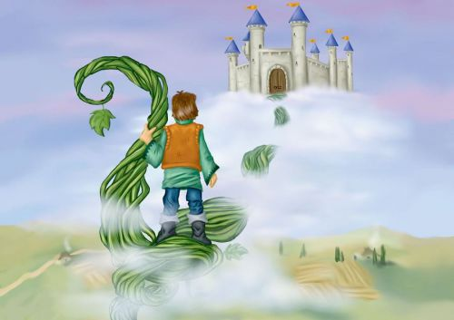
Focus: rising action, climax, falling action, resolution

Chapter 13
Focus: internal conflict, symbol, simile, metaphor

- What power does the gold statue have?

- To make the person who owns it rich.
- To become any person who is near it.
- To morph and change into the likeness of other people.
- To become hot or cold to the touch depending on the room’s temperature.

- What does the statue reveal about:

A. Finch: ____________________________________________________________________

_____________________________________________________________________

B. Jack: ______________________________________________________________________

______________________________________________________________________

C. Nick: _____________________________________________________________________

_____________________________________________________________________

- The statue becomes a symbol of what for each character?

- who they want to be
- their true, inner self; their character or nature
- Greed and violence
- Shame and regret

- Why is Nick “sickened” when he sees himself? (internal conflict)

_____________________________________________________________________________________________________________________________________________________________________________________________________________________________________________

- What mood does the diction on the top of pg. 146 set?

6. Greeneyes predicted that “…there will be other doors, won’t there?” (147) What
do the doors symbolize for Nick?

- choices
- escape
- captivity
- wealth

ADVERBS

An ADVERB is a word that describes a verb, adjective, or adverb. An adverb tells how, when, where, or how much.

Examples: The box was so full… (137).
how (much) full? so -- very, too, extremely, not/no

He went on, moving faster… (135).
moving how? faster -- quicker, slower, quieter

Still the wood scraped roughly over his cheek (136).
scraped how? roughly -- carefully, softly, loudly

…if he got his nerve up, return again for a second trip… (138).
return when? again -- soon, then, later

He pulled his hands through… (136).
pulled where? through -- out, near, here, there

Circle the adverbs in the following sentences. There could be more than one in a sentence! The word in italics at the end tells you what kind of adverb to look for.

1. “Grab as many valuables as he could safely carry…” how

2. “It would have fit easily in one of the ogre’s pockets…” how

3. “He reached out to touch it” where

4. “The gold rippled and swirled, as if it suddenly turned to liquid” when

5. “He saw the barely contained monster behind Finch’s handsome exterior…” how much

6. “…but they only sank deeper into the heart of the figurine” how

7. “…the shape began to change again” when

8. “…it floated gently over his golden twin” how

9. “He knew instantly that it was the voice of a giant” when

10. “There were windows here once, but stones blocked those openings now…” where and when

Chapter 14

Focus: conflict

- Why is Gullinda locked up?
______________________________________________________________________________________________________________________________________________________________
What type of conflict is this? Character vs. __________________

2. What is Gnasher’s evil plan?

______________________________________________________________________________________________________________________________________________________________
What type of conflict is this? Character vs. __________________

3. What decisions/choices does Nick have to make? (164-5)
______________________________________________________________________________________________________________________________________________________________
What type of conflict is this? Character vs. __________________

Prepositional Phrases

A prepositional phrase is a group of words that begins with a preposition and ends with a noun or pronoun.

Example: (preposition pronoun) (preposition noun) (preposition noun)

The giantess raised her hand, dipping it into one of the shafts of sunlight that entered through the broken ceiling.

( preposition noun )

Watch this video to understand prepositional phrases.

Prepositional phrases add details, information, and clarity to writing. Look at the passages below. Which has more details, more information, is more interesting?

A fat crow swooped. She snatched the bird. She popped it, crunched it, and swallowed it.

A fat crow swooped over Gullinda’s head. With alarming speed, she snatched the bird from the air. She popped it into her mouth, crunched it between her teeth, and swallowed it with a grimace (151).

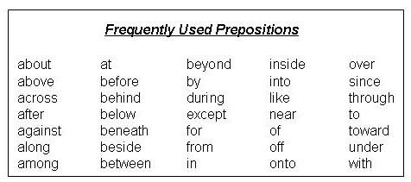

Circle the prepositional phrases in the following sentences. There could be more than one in a sentence! The number after the pg # tells you how many prepositional phrases are in the sentence!

1. The giantess raised her hand dipping into one of the shafts of sunlight that entered through the broken ceiling. 4

2. I haven’t had much in the way of food lately. 2

3. She plucked a piece of the plant from the pile and rolled it between her fingers. 3

4. Then he hobbled after the boy on his broken foot. 2

5. One day Gnasher took me by the hand and brought me to the treasure room. 2

6. I was a prisoner in that treasure room for a long, long time. 2

7. Nick’s face grew pale at the thought of those man-eating monsters loose in the world below. 3

8. Nick looked at the strange contraption along the wall. 2

9. The fibers went into those little holes around the first set of wheels. 3

10. He had passed through the back wall of the castle, into a kind of courtyard. 4

Chapter 15
Focus: turning point, setting, characterization,

Characterization:

- Nick realizes that there are two kinds of thieves in the world. Which one is he?
- Good people who succumbed to temptation and are forever guilty
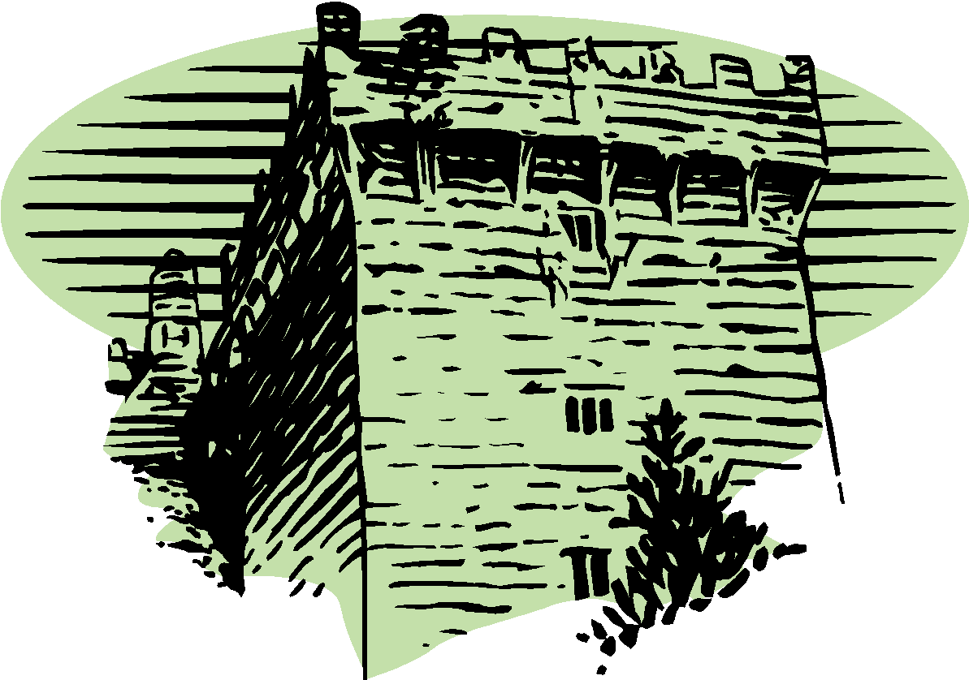
- Predators who murder and rob without a pang of regret
- Both of the above
- Neither of the above

- What is the turning point for Nick?

______________________________________________________

________________________________________________________

________________________________________________________________________

- Cite 3 examples of figurative language (simile, metaphor, personification)
from the chapter. Label each example to tell what type it is.

A. Type of figurative language_______________________________

_____________________________________________________________________

______________________________________________________________________

B. Type of figurative language _______________________________
___________________________________________________________________
___________________________________________________________________

C. Type of figurative language _______________________________
___________________________________________________________________
___________________________________________________________________

- Predict: How is Nick going to use the paper for the rescue of Gullinda?

_____________________________________________________________________________________________________________________________________________________________________________________________________________________________________________

Nick explores the ogres’castle. In the picture below, write in 10 prepositional phrases for items in the picture and you can draw on the picture and label with a prepositional phrase. Use 10 DIFFERENT prepositional phrases – DO NOT REPEAT PREPOSITIONS! An example is done for you.

in the sky

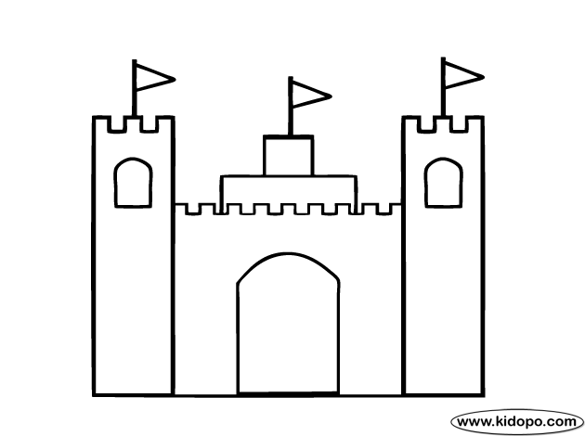

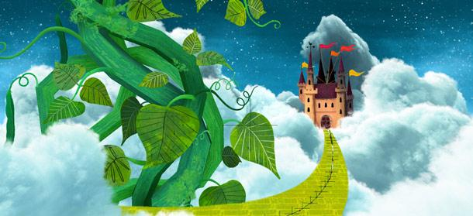
Chapter 16

Focus: indirect characterization

- What is the cause of Jack’s guilt?

_________________________________________

_____________________________________________________________________________

_____________________________________________________________________________

2. From the indirect characterization in this chapter, which best describes Gullinda?

- evil and cruel
- weak and pitiful
- unforgiving and vengeful
- kind and forgiving

3. What is Gullinda’s message to Jack?

_____________________________________________________________________________________________________________________________________________________________________________________________________________________________________________
_______________________________________________________________________________

Write 5 prepositional phrases from this chapter followed by the page number. Be sure each starts with a different preposition.

Example: at the abandoned farm (178)

1. _________________________________________________________________________

2. _________________________________________________________________________

3. _________________________________________________________________________

4. _________________________________________________________________________

5. _________________________________________________________________________

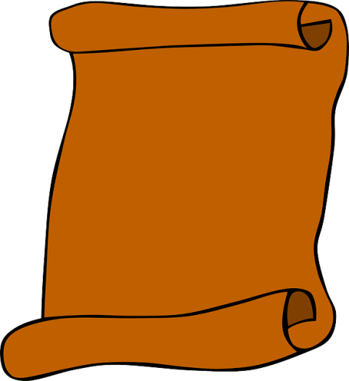
Chapter 17
Gallinor,
I have escaped from your prison. See for yourself.
Mother
Focus: suspense, conflict, theme

Use these lines from page 190-191 to help answer #1.

Imagine that,” said Guillina, chuckling. “A little one like you outwitting the clever Gnasher!”
…
“No! You’ve been a prisoner long enough. I don’t want them to catch you again. I’m small enough to get away with, though. They’ll never know I was there.”

1. What is the inferred theme from the passage above?

______________________________________________________________________________

______________________________________________________________________________

2. Suspense: This chapter has many suspenseful complications; tell three.

- ________________________________________________________________________

- _________________________________________________________________________

- _________________________________________________________________________

3. What do you learn about the character of Finch in this chapter?

- He is a coward
- He is scared
- He thinks only of himself
- All of the above

4. What does Finch make Nick believe at the end of the chapter?

____________________________________________________________________________

____________________________________________________________________________

_____________________________________________________________________________

5. Make a connection: Connect something (event, character, detail, etc) from this chapter to -- 1) your life, 2) the world (present or historical), 3) another text/movie, or 4) an earlier chapter in this book. Choose ONE from this list and clearly and thoughtfully explain the connection you are making.

___________________________________________________________________________

___________________________________________________________________________

___________________________________________________________________________

___________________________________________________________________________

___________________________________________________________________________

SUBJECTS AND VERBS

The subject and verb of a sentence will NOT be in a prepositional phrase.

Identifying prepositional phrases will make finding the subject and verb of the sentence easier!

Example: Gnasher hurled the bag of game to the floor .

prep phrase prep phrase

In the following sentences draw boxes around the prepositional phrase(s) and then underline the subject once and the verb twice.

1. A pair of strange antlers stuck out from the sack…

2. After fumbling for the right key, he unlocked the door and kicked it in .

3. The gaps in the ceiling were unreachable.

4. In the prison room, all was still for a moment.

5. The giantess hugged him tenderly and patted him on the back with the tips of her fingers.

6. A few of the animal bones were left on the floor of Nick’s cage .

7. Finch shoved Nick into the path of the ogre and ran.

8. With a grunt of disappointment, Basher withdrew his prey from his mouth.

9. With a pair of his smallest keys, he unlocked the doors.

Chapter 18

Focus: suspense, characterization, conflict

- Why does Gnasher want to invade the land of the little people? (new conflict)
_____________________________________________________________________________________________________________________________________________________________________________________________________________________________________________

2. Indirect characterization: how do you know that …

Opinion Statement | Proof: cite textual from the chapter to prove that…
A. Nick is clever. | 1.
B. Nick is kind and caring. | 2.
C. Finch is selfish and evil. | 3.

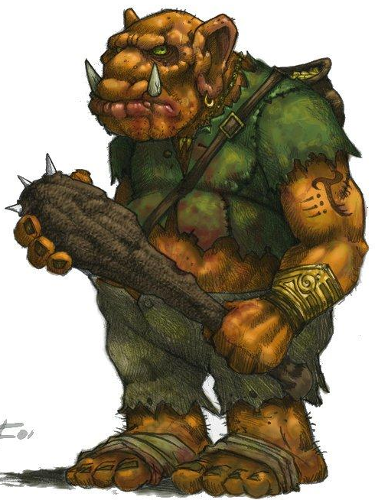
3. The events in the last half of the chapter create…

- theme
- turning point
- climax
- suspense

Chapter 19
Focus: static and dynamic character, suspense

- What kind of character is Nick? static or dynamic

How do you know? ___________________________________________________________

____________________________________________________________________________

- What kind of character is Finch? static or dynamic

How do you know? ___________________________________________________________

____________________________________________________________________________

3. How does Finch die (spoiler!)? __________________________________________________

____________________________________________________________________________

MAD LIB

Read the passage below noticing the underlined words or phrases. Then, fill in the blanks with the appropriate part of speech. Be creative but logical with your word choices.

But getting off the cart was a challenge that Nick had not considered. The platform towered high above the ground. Below him the mist hovered a few feet over the rocks. As breezes whipped along the edge of the cloud island, they made the vapors swirl. Part of the ground would be revealed for a moment, and it was treacherous, full of cracks and craters and sharp jutting stones. He was likely to break his leg if he jumped.

But getting ________________________was a challenge that Nick had not considered. The platform _______________high above the ground. Below him the mist hovered a few feet over the rocks. As breezes whipped _____________________of the cloud island, they made the vapors swirl. Part of the ground would be revealed for a moment, and it was___________________, full of cracks and craters and sharp jutting stones. He was likely to break his __________if he jumped.
prepositional phrase
vivid verb
adjective
noun
prepositional phrase

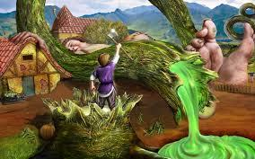
Chapter 20 Focus: climax, falling action

- How do Nick and Jack try to stop the ogres from coming down the beanstalk?

_________________________________________________________________________

_________________________________________________________________________

- How is Basher killed?

_________________________________________________________________________

_________________________________________________________________________

- How does Gnasher’s evil plan for world domination fail?

_________________________________________________________________________

_________________________________________________________________________

_________________________________________________________________________

4. Why is this the climax of the novel?

_________________________________________________________________________

_________________________________________________________________________

_________________________________________________________________________

5. Falling Action: How are the major conflicts resolved?

Conflict | Resolution - complete sentence!
1.Ogres try to rule the world. | 1.
2. Nick is ashamed of himself. | 2.
3. Nick is an unwilling thief in Finch’s band. | 3.
4. Jack’s guilt ruins his life. | 4.

MAD LIB

Read the passage below noticing the underlined words or phrases. Then, fill in the blanks with the appropriate part of speech. Be creative but logical with your word choices.

He got up, clutching his bruised and aching throat, and ran to the ax. He pulled furiously on the handle, but it slipped out of his hand, filling his hand with splinters, and he fell into the dust again. The beanstalk was rocking harder now. More pieces rained onto the ground. Now Nick could see an ogre, still high above, but coming fast, bellowing horribly.

Your turn:

He got up, clutching his bruised and aching throat, and ran to the ax. He pulled

________________________ on the handle, but it slipped out of his hand, filling his hand with
adverb

splinters, and he fell _______________________________again. The beanstalk was rocking
prepositional phrase

harder now. More pieces ____________________ onto the ground. Now Nick could see an
vivid verb

ogre, still high above, but coming fast, bellowing_______________________.
adverb

In these last 4 chapters, find and write…

A. six vivid verbs with page number.

1. 2. 3.

4. 5. 6.

B. six awesome adjectives with page number.

1. 2. 3.

4. 5. 6.

C. three sentences you like and underline the subject once, the verb twice and circle any
prepositional phrase(s). Include the page number.

- ________________________________________________________________________
________________________________________________________________________
2. __________________________________________________________________________
__________________________________________________________________________

3. __________________________________________________________________________
__________________________________________________________________________

Chapters 21-22 Focus: falling action

- From whose point of view is Ch. 22 told? _________________________

- How does Gnasher die? _____________________________________________________

_________________________________________________________________________

_________________________________________________________________________

- Why doesn’t Gullinda save him? ______________________________________________

_________________________________________________________________________

Chapters 23-24 Resolution

1. What becomes of Nick? ________________________________________________________

____________________________________________________________________________

2. What lesson does Nick learn? (theme) _____________________________________________

____________________________________________________________________________

3. What is the importance of the final scene, “Then a pod emerged from a flower. It hung like a beacon, fat with beans, glowing with a milky green light in the cool black night” (275)?

- Nick will never be hungry again because he can eat the beans.
- The soil in the valley is no longer suffering from a drought.
C. These are magic beans and a similar situation could happen all over again.
D. Finch will come back to life and steal the beans.

4. What will happen to Nick in the future? If you added another chapter, what would you have happen with Nick?
____________________________________________________________________________
____________________________________________________________________________
5. Of all the themes presented in this novel, which one do you think is the most important? Why?
_____________________________________________________________________________

_____________________________________________________________________________

_____________________________________________________________________________

