The Thief and the Beanstalk
Chapters 7-12
(Rising Action)

Answer all questions in complete sentences unless fill in the blank or multiple choice.

Chapter 7 (pgs. 60-77)
Focus: internal conflict, theme, diction, mood, figurative language

- Internal Conflict: Describe the “fix” that Nick is in? (on page 63)

_______________________________________________________________________________

How does this build suspense/drive the plot toward the climax?

_______________________________________________________________________________

- Diction & Mood: top of page 67

List 3 examples of diction (word choice) the author uses to describe Jack’s paintings.

____________________ ____________________ ____________________

Why? What mood does this diction set? _________________________________________

3. What does this diction tell the reader about Jack’s feelings toward his “great adventure”?

_______________________________________________________________________________

_______________________________________________________________________________

4. “That’s the trouble with stolen goods, boy,” said Jack….”They’re always more of a burden then you expect” (70) This is an example of – (circle ALL that apply)
- simile
- metaphor
- theme
- personification
- diction

Ch. 7 continued

Diction: deliberate, thoughtful word choice by the author to create a mood or feeling.

5. Create a list of words (at least 5) that you would use to create a mood of…

joy/happiness | fear/terror
1.  2.  3.  4.  5. | 1.  2.  3.  4.  5.

Chapter 8 (pgs. 78-89)
Focus: sensory imagery, diction, figurative language

- After leaving Jack’s house, where does Nick go and what does he do?

_________________________________________________________________________________

_________________________________________________________________________________

- Sensory Imagery: pages 83-85
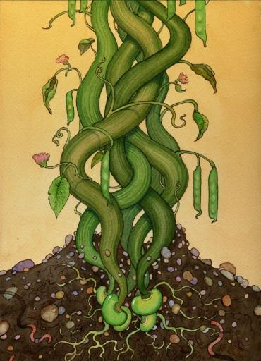
The author uses a lot of sensory imagery to help the reader feel he/she is a part of the scene of the emerging beanstalk. Carefully annotate in your book:

- What do you see? (in pink)
- What do you feel/touch? (in green)
- What do you hear? (in blue)

- The author also uses diction to create a mood for this event. (pgs. 83-85)

Describe the mood created by the author. ____________________________________________________

What diction (words) did the author use to set this mood? (give three)

A._________________ B. __________________ C.________________

VERBS can be used to show specific actions of the subject.

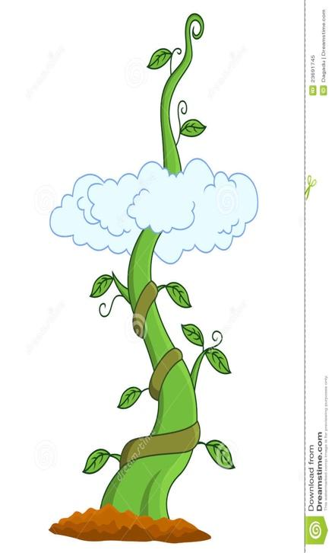
A vivid verb is one that creates a more complete, distinctive mental picture for the reader.

For example: The mirror shattered or The mirror broke?
Which verb is more descriptive, clear, and vivid?

5. List 10 vivid verbs and page number from this chapter that you noticed:

Example: scattered (84)

- 2.

3. 4.

5. 6.

7. 8.

9. 10.

Chapter 9 (pgs. 90-100)
Focus: setting, complication, foreshadowing, suspense, figurative language

1. Which of the following is an example of a character vs. nature conflict:

- “…green tendril wrapped itself gently…”(92)
- “Raucous crows were everywhere…glassy black eyes.” (97)
- “The boar came around the tree and lunged at him”.(98)
- “…a violent gust of wind swept over the crest of the ridge…”(90)

Draw the cloud island in the box below. Then give three citations to prove your drawing is accurate.

2. Give three citations: Textual evidence (citation with pg. numbers) to prove your drawing is accurate.

- ___________________________________________________________________________

- ___________________________________________________________________________

- ___________________________________________________________________________

3. How does Nick’s struggle with the boar add suspense?

_____________________________________________________________________

_____________________________________________________________________

4. “The flag is a signal, he thought before everything faded away. Someone will be coming….” (100) is an example of what literary term?
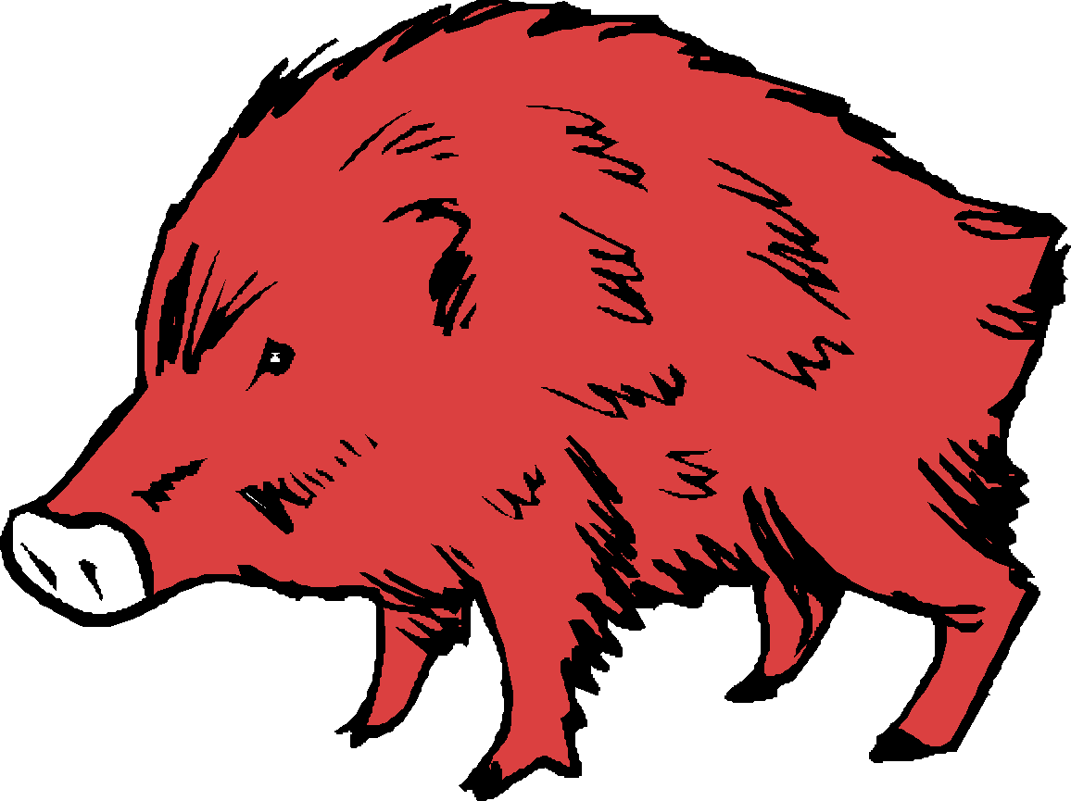
A. foreshadowing
B. theme
C. internal conflict
D. flashback

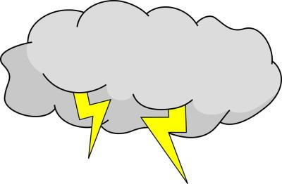

Chapter 10 (pgs 101-106)

Focus: internal conflict, theme, figurative language

- What type of conflict has Jack been facing since he came down from the beanstalk so long ago?

________________________________________

What does Ann decide about Jack’s conflict? Do you agree?

______________________________________________________________________________________

______________________________________________________________________________________

- On pg. 103, third paragraph: What message about stealing is Jack trying to explain to Ann? (Theme)

_____________________________________________________________________________________

_____________________________________________________________________________________

_____________________________________________________________________________________

VERB PHRASES

Some sentences have a single verb. Example: A loud snort came from his right.

Sometimes sentences have verb phrases. A verb phrase is the main verb and all the helping verbs.
Example: He was looking right into that awful pink eye.
Example: Nick could even see flashes of lightning here and there.

Here is a list of helping verbs.

Maybe Mr. Do Should Have a Will
may  might  must | be  being  been  am  are  is  was  were | do  does  did | should  could  would | have  had  has | will  can  shall

Underline the subject once and the verb phrases in the following sentences twice.

Example: He should be home by tomorrow morning…

- “Someone will be coming…”
- “Henry could scarcely get the words out…”
- “… they were going to murder me…”
- “…the boy whose intervention had saved Henry’s life must be Nick.”
- “Ann was bouncing on her toes.”
- “He was looking east…”
- “And all of you should be armed…”
- “ …he had lived with Jack all his life.”
- “Now a thief is climbing a beanstalk.”

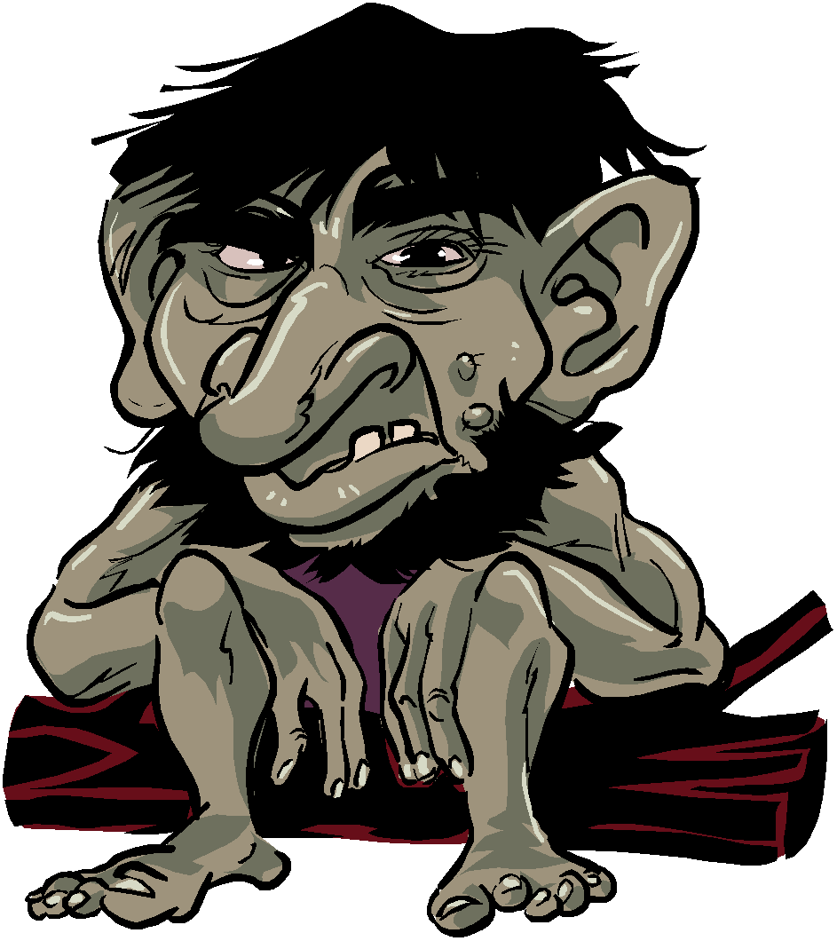
Chapter 11 (pgs. 107-129)

Focus: characterization, foreshadowing, diction, complication, suspense, figurative language

- Cite one piece of textual evidence to prove that the ogres are clever:

_______________________________________________________________________

_______________________________________________________________________

- “Greeneyes” speaks in riddles. Tell 2 things he hints or foreshadows will happen.

A.

B.

3. The hen that lays the golden eggs, the magic beans, the doors that Greeneyes speaks of all emphasize the theme of -

A. being honest

B. loving family

C. changing clothes

D. making choices

4. Look at the diction used to describe the ogres’ castle. (pgs. 119-121) List three examples of diction-
intentional, thoughtful word choice.

_______________________ _______________________ _______________________

Describe the mood. ______________________________________________________________________

5. Compare/contrast the brothers. Give at least 2 details for each section of the diagram.

Ogre 1: (rat-faced ogre) Ogre 2: Basher (toad-faced ogre)
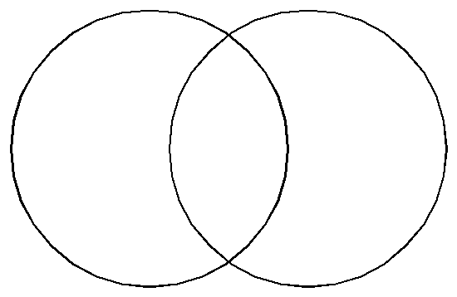

COMPLETE SENTENCES

Every sentence must have a subject and a verb and express a complete thought.

The SUBJECT is a noun or pronoun and tells who or what the sentence is about.

The VERB tells what the subject of the sentence is doing (action) or is like (linking).

Example: Nick looked for the closest place to hide (108).
Sentence is about? Nick = subject of the sentence
What did mom do? looked = verb of the sentence

Example: The fingers were too long (109).
Sentence is about? fingers = subject of the sentence.
What are the fingers like? long
What links fingers to long? were = verb of the sentence

Remember that some sentences have verb phrases and the common linking verbs are--
am, is, are, was, were, be, being, been, become, seem

Neither the subject or verb will be in a prepositional phrase.

Underline the subject of each sentence once and the verb twice.

1. A dense brush grew a few yards away.

2. Hideous jewelry decorated the ogre.

3. They were terrible pink eyes with blood-red irises at the center.

4. At last the ogre turned back toward the castle.

5. This adventure had taken a malignant turn.

6. It was a loud, long sip.

7. The stranger had called Nick by his name.

8. Nick glanced at the hour glass.

9. The stranger’s cryptic answers were maddening.

10. Soon the road emerged from the forest into a meadow of tall grass.

11. An entire village could have fit inside its outer walls.

Chapter 12 (pgs. 130-150)

Focus: theme, mood, turning point, figurative language

- How does the growing beanstalk affect the surrounding land?

__________________________________________________________________________

__________________________________________________________________________

__________________________________________________________________________

- Author’s purpose: This chapter about Henry is really not necessary to the novel. It could be taken out and the story would be just fine. Why do you think the author put it in?

- To show that Jack’s men now actually believe in the story of the beanstalk
- To show the reaction of Jack’s men to the beanstalk
- Emphasize the theme that facing your fears make them go away
- Emphasize how scared Henry is of the band of thieves

3. What is Henry’s turning point? How does he change?

__________________________________________________________________________

__________________________________________________________________________

__________________________________________________________________________

COMPOUND SUBJECTS and VERBS

Some sentences have more than one SUBJECT joined by a conjunction called a compound subject.

Conjunctions include -- for, and, nor, but, or, yet, so (FANBOYS)

Example: The trees and underbrush were full of chirping animals…

Sentence is about? trees and underbrush

Some sentences have more than one verb joined by a conjunction called a compound verb.

Example: The ogre stood over the dead bore and prodded it with his foot.

Sentence is about? ogre

What did the ogre do? stood and prodded

Underline the subject of the following sentences once and the verbs twice.

1. Jack and his men approached the crest of the hill.

2. Spears and other weapons were heaped in the back of the wagon.

3. Abruptly, the ogre stopped and turned back toward the clearing.

4. Nick flopped onto his back and filled his chest with a deep draft of air.

5. He brought it to his lips and drank.

6. Nick searched his mind and found the answer.

7. Everything here had been pulled up or hacked away.

8. He arched his back and stretched his arms.

9. Without hesitating, he slid underneath and entered the giant’s castle.

10. Basher reached one arm across the table and swept the whole mess onto the floor.

11. Henry ran a hand across his forehead and through his hair and sighed deeply.

12. A few feet to Henry’s right, the earth heaved and split open.

